**Title**

Climate-driven decreases in aspen’s distribution and opportunities for future expansion across the Southern Rocky Mountains

**Authors**

Sarah J. Harta,1, Asha Paudela, and Maxwell C. Cookb,c

**Affiliations**

a - Department of Forest and Rangeland Stewardship, Colorado State University, Fort Collins, CO 80523, USA

b - Department of Geography, University of Colorado Boulder, Boulder, CO 80309, USA

c - Earth Lab, Cooperative Institute for Research in Environmental Sciences (CIRES), University of Colorado Boulder, Boulder, CO 80309, USA

1 - Corresponding author; Email address: Sarah.Hart@colostate.edu

# Highlights

* An ensemble model explained 79% of the variation in aspen occurrence.
* Interactions between temperature and precipitation influence aspen’s distribution.
* Climate change will likely lead to decreases in aspen habitat suitability.
* Dispersal may limit the potential for aspen range expansion.

# Abstract

Understanding how species distributions may shift in response to changing climate is critical for climate adaptive management. Across western North America, there is a particular need to understand how climate change will impact the distribution of trembling aspen (*Populus tremuloides* Michx), a species which has already experience impacts from widespread warm and dry conditions during the 21st century. These impacts are varied across topoedaphic site conditions, prompting questions regarding how and where shifting climate will impact this species. To address these needs, here we (1) use fine-scale remotely sensed distributions of aspen to understand the abiotic drivers of aspen’s distribution, (2) produce maps of habitat suitability under current and future climate, and (3) characterize the potential for aspen to expand into new areas. We built an ensemble species distirbution model for aspen that explained 79% of variation in occurrence across the Southern Rocky Mountain Ecoregion (SRME). Our model showed that interactions between temperature and precipitation were important in constraining aspen’s distribution. To assess future suitability, we used two future climate scenarios from the sixth generation Coupled Model Intercomparison Project. Relative to the 1981-2010 period, we found average aspen habitat suitability across the SRME for 2011-2040 decreased by 8.4% under both scenarios, largely at lower elevations. Nonetheless, our model suggests that large areas of the SRME may be suitable for aspen expansion. However, most of these areas are located more than 100 meters from existing aspen patches, thereby limiting expansion to establishment from seed or artificial regeneration practices. By combining a SDM with fine-grain maps of aspen’s current distribution, this study provides a novel assessment of how climate change may influence existing aspen stands and where might be suitable for future expansion - insights that are key for effective management.

# Keywords

Trembling aspen; Southern Rockies; SDMs; Ensemble modeling; Climate change; Forest management

# Introduction

Global warming has already and will continue to impact many ecosystems around the world with important consequences for society (Parmesan and Yohe, 2003). These effects may be particularly pronounced in high-elevation forested ecosystems, where warming is occurring more rapidly (Pepin et al., 2015), plant species are often characterized by slow migration rates (Malanson and Cairns, 1997), and high topoedaphic complexity may limit upslope migration (Graae et al., 2018). In order to anticipate and mitigate the potential changes in forest ecosystems, forest managers require a better understanding of how species distributions may shift at scales relevant to management activities.

Species distribution models (SDMs) - correlative models that associate species distribution data with environmental characteristics (Elith and Leathwick, 2009) - have been commonly used to understand how species ranges may shift in response to climate change (Ehrlén and Morris, 2015). Despite their widespread use, many SDMs have only limited applicability for forest management and conservation planning. For instance, many SDMs are produced using coarse-scale gridded climate data (i.e. 4 x 4 km), which may artificially inflate the area of predicted suitable habitat (Franklin et al., 2013; Seo et al., 2008). Second, many SDMs are spatially-biased because they have been constructed using species occurrence data from herbaria, species atlases, field surveys, expert range maps, and citizen science (He et al., 2015), which typically include only information on species presence and are biased towards areas that are easier to access (e.g., near roads) (Yackulic et al., 2013). Third, many SDMs lack adequate documentation of their modeling approach, thereby limiting accurate assessments of reliability (Zurell et al., 2020).

Recent advances in computation power, geospatial technologies, and open-data science are paving the way for a new generation of SDMs. For example, greater computation power and publicly available data and code have reduced many of the barriers that historically limited scientists from incorporating high resolution climate data in SDMs (Kusch and Davy, 2022). Scientists have also recently begun using remotely sensed datasets that provide spatially-continuous information on both species presence and absences to build SDMs with less spatial bias (He et al., 2015). Importantly these remotely sensed data products can also allow for more robust predictions of range shifts by incorporating locations of known populations and information on dispersal distances (Randin et al., 2020). Finally, expectations for the reproducibility and transparency of ecological research are rapidly growing (Powers and Hampton, 2019), as evidenced by the recently published standardized open-science protocols for building and sharing SDMs (Zurell et al., 2020).

Across western North America there is a particular need for updated SDMs that provide insight into how the distribution of trembling aspen (*Populus tremuloides* Michx) (hereafter aspen) may shift in response to climate change. In this region, aspen is the most widely distributed tree species and it is highly valued for its contributions to biodiversity, aesthetic quality, soil carbon sequestration, and the potential to mitigate wildfire activity, among other things (Campbell and Bartos, 2001; Mitton and Grant, 1996; Rogers et al., 2020). Importantly, recent widespread warm and dry conditions during the early 21st century have been associated with changes in the demography and distribution of aspen, highlighting the potential for future climate climate to drive dramatic range shifts. For instance, during the early 21st century rapid crown dieback and mortality and poor regeneration (i.e., sudden aspen decline; SAD), was observed across much of aspen’s distribution, particularly at more arid sites (Hanna and Kulakowski, 2012; Worrall et al., 2013). While in relatively cool and wet areas affected by recent bark beetle outbreaks and wildfires, aspen has increased in dominance and even shown upward range expansion (Andrus et al., 2020; Nigro et al., 2022).

The objectives of this study are to: (1) use fine-scale remotely-sensed data on the presence and absence of aspen to better understand how climate, topographic, and soil variables influence aspen’s distribution; (2) produce maps of the area suitable for aspen under current and future climate conditions; and (3) integrate future habitat suitability along with with maps of existing aspen coverage to characterize the potential for aspen to expand into new areas. We improve upon earlier SDMs of aspen, notably Rehfeldt et al. (2015; 2009; 2006) and Worral et al. (2013), to build a model that: (1) integrates data from the most recent phase of Coupled Model Intercomparison Project (CMIP6); (2) follows the standardized protocols developed by Zurrell et al. (2020); (3) makes use of a novel 10-m remotely sensed map of aspen cover for Cook et al. (2024); and (4) integrates information about aspen’s distribution and dispersal to better understand the potential for range shifts to occur.

# Materials and Methods

## Study area

The Southern Rocky Mountain Ecoregion (SRME) is a mountainous region an area of approximately 145,700 km2 that extends from southern Wyoming to northern New Mexico (Fig. 1). The SRME consists of rugged, topography with elevation ranging from 1450 m to above 4400 m, seven mountain ranges that largely trend north-south, and four Intermontane basins (Drummond, 2012). The climate of the SRME is characterized by a continental climate, with hot summers (mean July maximum temperature of 24.5°C) and cool winters (mean January minimum temperatures of -12.3°C), and moderate precipitation (mean annual precipitation of 625 mm), most of which falls as snow (Lukas et al., 2014; Rodman et al., 2021). At local scales, the climate is driven by elevation gradients, the prevailing westerly winds, and the north-south orientation of the mountains. Temperatures are warmer at lower elevations, while more precipitation falls at higher elevations, particularly on the windward side of the Rockies (Lukas et al., 2014). Summer precipitation patterns exhibit a distinct latitudinal gradient, where more southern locations often receive more precipitation due to the North American Monsoon system (Lukas et al., 2014).

Ecosystems of the SRME correspond with topoclimatic patterns; low elevation valleys and intermountain basins are dominated by grasslands and shrublands, forests occupy intermediate elevations, while grasses, sedges, cushion plants, forbs, mosses, and lichens dominate cold, alpine elevations (Comer, 2001). Within the ca. 55% of the SRME that is forested (Drummond, 2012), tree communities also follow elevation gradients. Lower montane forests (< 2,300 m) are generally composed of ponderosa pine (*Pinus ponderosae*) woodlands, piñon (*Pinus edulis*) and juniper (*Juniperus* spp.) woodlands, and gamble oak (*Quercus gambelii*) shrublands. Forests of the upper montane zone (ca. 2,300 - 2,800 m) are dominated by ponderosa pine-Douglas fir mixed conifer systems, quaking aspen, and lodgepole pine (*Pinus contorta*). Forests of the subalpine zone (ca. 2,800 m - 3,200 m) are dominated by Engelmann spruce, subalpine fir, and to a lesser extent limber pine (*Pinus flexilis)* and Rocky Mountain bristlecone pine (*P. aristata*). Forests dynamics across the SRME are strongly shaped by climate-sensitive disturbances, notably wildfires, outbreaks of native bark beetles, and windstorms [Peet (1981); Baker and Veblen (1990); Veblen et al. (1994); Veblen et al. (2000); Chapman et al. (2012); Hart et al. (2014)).

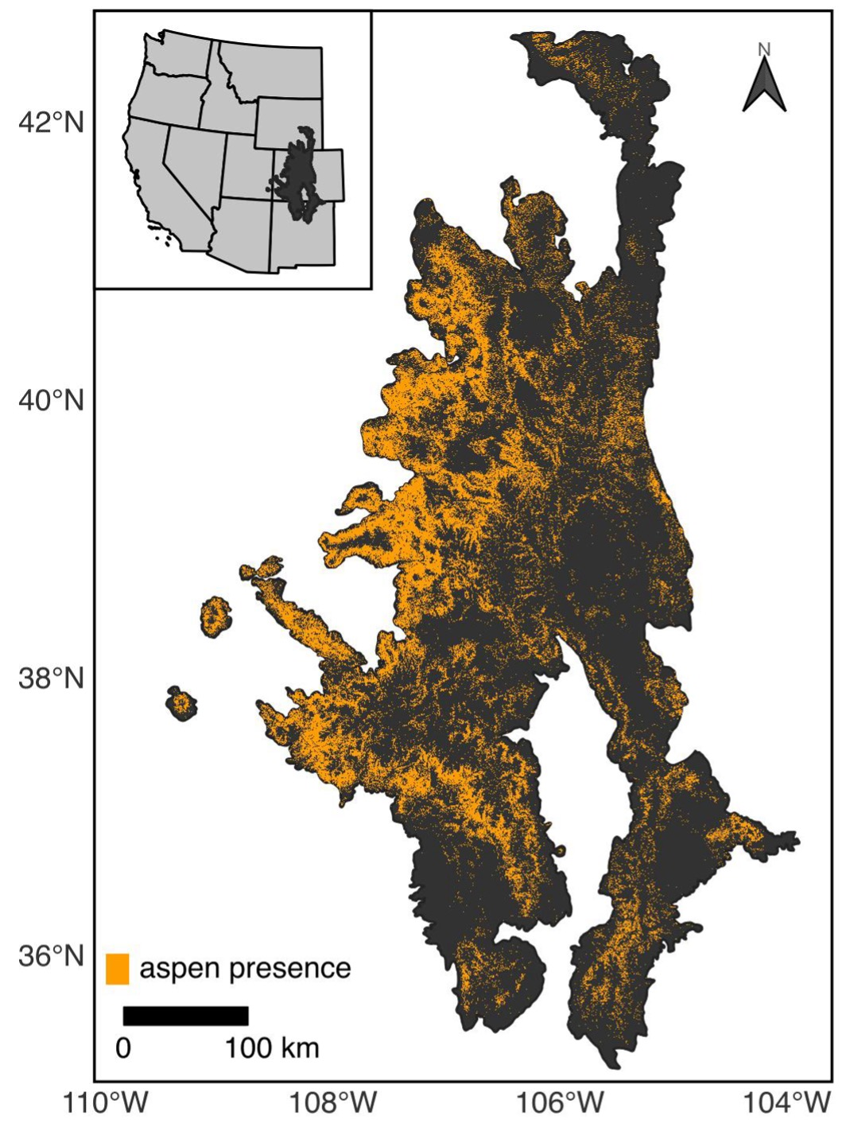

Figure 1: The Southern Rocky Mountain Ecoregion and current distribution of aspen.

## Modeling overview

Here we follow the ODMAP (Overview, Data, Model, Assessment and Prediction) protocol to develop data products that provide forest managers and other end users with a more complete understanding of the data limitations (Zurell et al., 2020).

### Data

#### Species occurrence data

To build SDMs, we used a 10-m gridded map of aspen presence-absence produced by Cook et al. (2024). Briefly, this dataset was produced in Google Earth Engine using 10-m seasonal composite imagery from the Sentinel-1 and Sentinel-2 sensors. The map represents the distribution of aspen in ca. 2019 and is characterized by high accuracy (0.93 average F1-score). To generate our SDMs, we aggregated the data from 10-m to 90-m, a scale relevant to management (Rehfeldt et al., 2015).

#### Predictor variables

To understand how climate is related to the contemporary distribution of aspen and the potential for future climate change to drive range shifts, we obtained gridded climate data from the AdaptWest Project (2022). This dataset consists of both current and future climate data that are downscaled to 1 x 1 km resolution using the ClimateNA software (version 7.3) (Wang et al., 2016) . Contemporary climate conditions, defined here as climatalogical norms for the 1981-2010 period, were generated from 4 x 4 km climate data provided by the PRISM Climate Group (2021). Future climate conditions were generated from data included in the sixth phase of Coupled Model Intercomparison Project (CMIP6). Here we used projections of future climate for the periods 2011-2040, 2041-2070, and 2071-2100. Given considerable uncertainty about future emissions, we compared two scenarios (i.e., Shared Socioeconomic Pathways; SSPs) generated under CMIP6, SSP2-4.5 and SSP5-8.5. SSP2-4.5 describes an intermediate scenario characterized by moderate increases in emissions through 2040 followed by a decline, while SSP5-8.5 describes a more extreme situation where emissions increase through 2100 (Riahi et al., 2017). In addition to uncertainty about societal decisions about greenhouse gas emissions represented in the SSPs, variation exists among the more than 50 atmosphere-ocean general circulation models (AOGCMs) included in CMIP6. Because of differences in complexity, assumptions, and parameterization of AOGCMs, not all forecasts are equally useful for regional planning purposes. Here we make use of an ensemble dataset constructed from eight AOGCMs identified by Mahony et al. (2022) as being appropriate for regional applications in North America, including species distribution modeling.

To characterize the climate space that aspen currently occupies, we examined 34 biologically-relevant climate variables commonly used in species distribution models (Table 5). Broadly, these variables characterize temperature, precipitation, seasonality, and interactions between precipitation and temperature. To avoid collinearity between climate predictors, we calculated pairwise Pearson correlation coefficients. When |r|>0.75, we removed variables based on existing research (Table 5). Where evidence was similar, we used univariate random forest (RF) models to evaluate the potential explanatory power of each predictor. The resulting dataset consisted of six climate variables: (1) an annual dryness index (ADI), (2) growing season precipitation (GSP), (3) the ratio of GSP to degree days above 5 °C (GSPDD5), (4) the ratio of GSP to mean annual precipitation (PRATIO), (5) mean annual relative humidity (RH), and (6) the difference between the mean coldest month temperature and the mean warmest month temperature (TD) (Table 1).

Given mountainous areas such as the SRME are characterized high topoclimatic variation (Franklin et al., 2013), we further downscaled our selected climate variables from a 1 km resolution to a 250 m resolution using gradient and inverse distance squared (GIDS) interpolation (Flint and Flint, 2012; Nalder and Wein, 1998), following methods outlined in Rodman et al. (2020). As ancillary data in the downscaling, we used a digital elevation model (DEM) from the USGS (2023).

In addition to climate variables, we also included data describing terrain and soils as predictors in our models. To account for the potential effects of local topographic variation on soil transport and water balance (Jones and DeByle, 1985), we used a 30-m DEM from the USGS (2023) to calculate the topographic position index [TPI; Weiss (2001)]. We calculated TPI for a 3-cell neighborhood (TPI3) to characterize fine scale topographic patterns (Rodman et al., 2020). To account for the effects of aspect and slope on local climate, we calculated the Heat Load Index [HLI; McCune and Keon (2002); McCune (2007)]. Both HLI and TPI3 were calculated in R using the *spatialeco* package (Evans and Murphy, 2021). Given soil properties may influence aspen demographic processes (Jones and DeByle, 1985), we obtained 30-m probabilistic maps of soil pH, the percentage of organic material, the percentage of clay, and saturated soil water content from the POLARIS database (Chaney et al., 2019). We did not include elevation, latitude, and longitude as predictors in our modeling because we assumed these relationships were only correlative (Araújo et al., 2019). We re-sampled soil and topographic predictors to a 90-m resolution by calculating the mean and projected the data to Universal Transmercator (UTM) Zone 13N to match the maps of aspen occurrence.

Table 1: Predictor variables tested for inclusion in modelling and their hypothesized relationship with aspen's distribution. Variables marked with an asterisk were removed prior to model building to reduce collinearity among predictors.

| Variable | Description | Expected relationship with aspen |
| --- | --- | --- |
| ADI | annual dryness index: (degree-days above 5 °C)^0.5 / (mean annual precipitation) | Fast-growing, short-lived species such as aspen typically have high water demand (Ireland et al. 2014). Thus high ADI has been linked with lower climate suitability for aspen (Rehfeldt et al. 2009, 2015). |
| DD_0* | degree-days below 0 °C | To prevent early development of new buds that may lead to injury, aspen phenology is requires a chilling period. Insufficient chilling periods may delay budburst (Man et al. 2017). |
| GSP* | growing season (Apr - Sep) precipitation (mm) | Greater precipitation during the growing season may alleviate summer moisture stress (Worral et al. 2013). |
| GSPDD5 | growing season precipitation degree day ratio: (GSP*DD5/1000) | Plant productivity is higher in areas with warmer temperatures and greater precipitation during the growing season (Rehfeldt et al. 2009). |
| PRATIO | mean precipitation ratio: (growing season precipitation) / (mean annual precipitation) | Evenly distributed precipitation (intermediate PRATIO) may promote aspen by limiting seasonal moisture stress (Rehfeltd et al. 2009) |
| RH | mean annual relative humidity (%) | Lower relative humidity leads to greater water loss via transpiration. To limit this loss, trees may close their stomata and thereby limiting photosynthesis. |
| TD | difference between MCMT and MWMT (°C) | Extreme seasonal variation in temperature may present physiological challenges to aspen (Worrall et al. 2013; Rehfeldt et al. 2015) |
| Clay | clay | High clay content may inhibit aspen growth (Jones and DeByle 1985) |
| OM | soil organic matter [log10(%)] | Aspen is expected grow better on soils with high organic matter content (Perala 1990) |
| SWC | saturated water content (m3/m3) | Aspen is expected grow better on soils with greater water holding capacity (Perala 1990). |
| pH* | soil pH | High soil pH may decrease the availability of nutrients and limit aspen growth (Zhang et al. 2013). |
| HLI | heat load index | Greater HLI may inhibit aspen, particularly at lower elevations and latitudes (Jones et al. 1985). |
| TPI | topographic position index | Aspen is expected grow better in valley bottoms (low TPI) and on benches (moderate TPI) than steep slopes (high TPI), where soil water content may be lower (Jones and DeByle 1985) We calculated TPI using neighborhoods of 3 (TPI3) and 15 (TPI15), however we retained only TPI3 because of high correlation among the two indices. |

### Modeling Approach

To characterize suitable habitat for aspen, we used four different modeling approaches commonly applied in species distribution modeling: generalized linear models (GLMs), generalized additive models (GAMs), random forests (RFs), and regularized gradient boosted tree (RGBTs). Here, we first overview our modeling approach before describing specifics for individual modeling techniques. All models were fit in *R* (R Core Team, 2022) using a *tidymodels* framework (Kuhn and Wickham, 2020).

To build GLM, GAM, RF, and GBT models, we first constructed a balanced data consisting of 10,000 pixels with aspen present and 10,000 pixels without aspen. To minimize the potential effects of spatial autocorrelation, pixels were selected so that they were separated by at least 1 km. To improve model fit and interpretability, all predictor variables were standardized by calculating standard scores. Using this dataset, we reduced our set of environmental predictors to minimize the potential effects of collinearity on model inference and projection. Specifically, we used the *spatialRF* (Wright and Ziegler, 2017a) to calculate variable inflation factors (VIF), which indicate when a predictor variable is a linear combinations of other predictor variables. We then iteratively removed variables until VIF<5 for all variables.

To build and evaluate models, we then split our dataset into equally-sized testing and training datasets. The testing dataset was further split to create five spatial cross-validation folds using the *spatialsample* package (Mahoney et al., 2023). We then tuned model hyperparameters using spatial cross-validation and identified the best hyperparameters based on the area under the receiver operator curve (AUC). To evaluate the capacity of our model to predict to new areas, we then fit the model using the best hyperparameters to each spatial cross-validation fold and assessed the variation in the AUC statistic. Given the model’s ability to predict aspen habitat in new areas, we then fit a final model to the training dataset and predicted the probability of aspen presence for the testing dataset. Using the *probably* package (Kuhn et al., 2023), we determined the probability threshold that maximized the Youden’s J statistic (Youden, 1950) and then calculated class-based accuracy statistics based on this threshold.

To better understand the environmental drivers of aspen’s distribution and assess model realism, we calculated variable importance scores for each model using a model-agnostic permutation-based approach. In this approach each variable is randomized and then the AUC statistic is compared with AUC for the full model (where data has not been randomized). We also evaluated the relationship between aspen presence and each predictor variable using accumulated local effects (ALE) profiles (Apley and Zhu, 2020). Variable importance and ALE were calculated in R using the *DALEX* (Biecek, 2018) and *ALEPlot* (Apley, 2018) packages.

#### Generalized linear models

GLMs are extensions of parametric linear regression adapted to distributions other than the normal distribution (Zuur et al., 2007). Here we constructed GLMs with a logit link function and a binomial error distribution to account for the structure of presence-absence data. We included both linear and quadratic effects for all variables, but did not explore any interaction terms. We fit GLMs using a Lasso regularization approach, which allows for model coefficients to be reduced to zero, thereby limiting model complexity and improving bias-variance tradeoffs (Hastie et al., 2009). Prior to fitting the model to the full training dataset, we tuned the lasso penalty term. GLMs were fit using the *glmnet* package (Friedman et al., 2010).

#### Generalized additive models

GAMs are a non-parametric extension of GLMs that are particularly useful when there is no *a priori* reason for fitting a particular relationship (e.g., linear, quadratic). Here, we constructed binomial GAMs with a logit link function using the *mgcv* package (Wood, 2011). In our model, we represented the relationships between the response and each predictor variable using thin plate regression splines, where the penalty term was adjusted to allow the term to be shrunk to zero. For all smooths, we set the k parameter, which sets the number of basis functions, to the default value of 10, after using built in diagnostic function from the *mgcv* package to confirm an adequate degree of complexity. To limit overfitting, we tuned the penalty term prior to fitting the model to the full training dataset. GAMs were fit using restricted maximum likelihood (REML), following recommendations from Pedersen et al. (2018).

#### Random Forests

RF models are an extension of classification and regression tree analysis (CART; Breiman et al. (1984)), a nonparametric approach where decision trees are used to explain the variation in the response variable by repeatedly splitting the data into more similar groups (Death and Fabricius, 2000). Tree-based approaches are useful for modeling nonlinear relationships and complex interactions among variables, which often characterize ecological data (Cutler et al., 2007; Death and Fabricius, 2000). RF builds upon bagging methods, where many trees are built using random samples (with replacement) of the training data and predictions are generated from the ensemble set of trees. While bagging reduces some of the overfitting issues associated with CART, RF methods also limit the number of variables to consider at any given split to a random subset and the complexity of each tree by limiting splits to only nodes with a minimum number of data points. The inclusion of these hyperparameters results in less correlation among trees and thus better bias-variance tradeoffs (Cutler et al., 2007). Prior to fitting the model to the full training dataset, we tuned these hyperparameters, while holding the number of trees constant at 1000. RF models were fit using the tidymodels implementation of the *ranger* package (Wright and Ziegler, 2017b).

#### Regularized gradient boosting trees

Gradient boosted trees (GBTs) are also an ensemble-based extension of CART (De’ath, 2007). In contrast to RF where trees are built in parallel, individual trees in a GBT ensemble are constructed iteratively so that each successive tree attempts to improve upon predictions made by the previous tree (Friedman, 2001). To improve bias-variance tradeoffs, GBTs incorporate hyperparameters that control the rate at which the boosting algorithm adapts, and introduce randomness into the tree construction by sampling both variables (i.e., columns) and cases (i.e., rows) used to fit the model. RGBTs expand upon these approaches by incorporating regularization terms that constrain the depth of the tree and setting limits on the amount of gain in model fit required to further partition a node of the tree. We tune these hyperparameters prior to fitting the model to the full training dataset. RGBTs were fit using the R package *xgboost* (Chen et al., 2023).

#### Model Ensemble

To account for uncertainty due to modelling approach (Araujo and New, 2007), we generated ensemble predictions by combining predictions for each model. Specifically, we calculated a weighted probability of occurrence from all four presence-absence models. We assigned weights based on the AUC statistic. We then comparing the ensemble prediction probability with the testing dataset and determined the probability threshold that maximized the Youden’s J statistic (Youden, 1950). We used this threshold to calculate class-based accuracy statistics.

### Forecasting change in aspen habitat

To understand how future changes in climate may affect the distribution of aspen, we used the ensemble model to forecast the probability of aspen habitat suitability under the SSP2-4.5 and SSP5-8.5 scenarios for the 2011-2040, 2041-2070, and 2071-2100 periods. We then used these probabilistic forecasts of aspen habitat suitability to forecast aspen presence and absence based on the optimal probability threshold (see 5.2.2.5). We then overlaid forecasts of aspen presence-absence with the map of existing aspen occurrence from Cook et al. (2024) to produce maps where changes in climate may lead to aspen gain, loss, or stability. Finally, given expansion will be constrained by dispersal, we used a moving widow approach to calculate the distance to the nearest existing stand of aspen for each gain pixel. Specifically, we quantified the presence of aspen with 3, 5, 7, 13, 25, and 47 cell neighborhoods (i.e., within 90 m, 180 m, 270 m, 540 m, 1080 m, and 2070 m).

# Results

## Model performance

The GAM, GLM, RF, and XGB models all accurately modeled the presence and absence of aspen across the study area. Spatial cross-validation revealed all models accurately predicted to new areas; across the five folds the mean AUC statistic (± standard error of the mean) was 0.81 ± 0.02, 0.82 ± 0.02, 0.83 ± 0.01, 0.83 ± 0.01 for the GLM, GAM, RF, and RGBT, respectively. When compared with the testing data, all models achieved an AUC greater than 0.84, indicating a good model fit (Table 2). When compared with the dataset of aspen presence derived from aerial photo interpretation, the ensemble model correctly predicted 80% of points (n=13896).

Table 2: Model performance statistics. Observed values are from independent testing data.

| Model | Accuracy | F measure | kappa | Precision | Recall | AUC | Sensitivity | Specificity |
| --- | --- | --- | --- | --- | --- | --- | --- | --- |
| Ensemble | 0.79 | 0.78 | 0.57 | 0.80 | 0.76 | 0.87 | 0.76 | 0.81 |
| GAM | 0.77 | 0.76 | 0.54 | 0.80 | 0.72 | 0.85 | 0.72 | 0.82 |
| GLM | 0.76 | 0.77 | 0.52 | 0.75 | 0.79 | 0.84 | 0.79 | 0.73 |
| RF | 0.80 | 0.80 | 0.59 | 0.79 | 0.81 | 0.88 | 0.81 | 0.78 |
| XGB | 0.79 | 0.79 | 0.58 | 0.80 | 0.77 | 0.88 | 0.77 | 0.81 |

While the ensemble model performed well, there were spatial patterns in the residuals (Fig. 2 and 8). Relative to true positives (i.e., pixels where aspen was present that were correctly classified), false negatives (i.e., pixels where aspen was present but the model predicted absence) were concentrated at more eastern longitudes. False negatives were also common where the percent aspen cover within the 90 x 90 m pixel was low (median value of 8.6%). Generally, false positives tended to occur at similar geographies as true positives (Fig. 2 and 8).

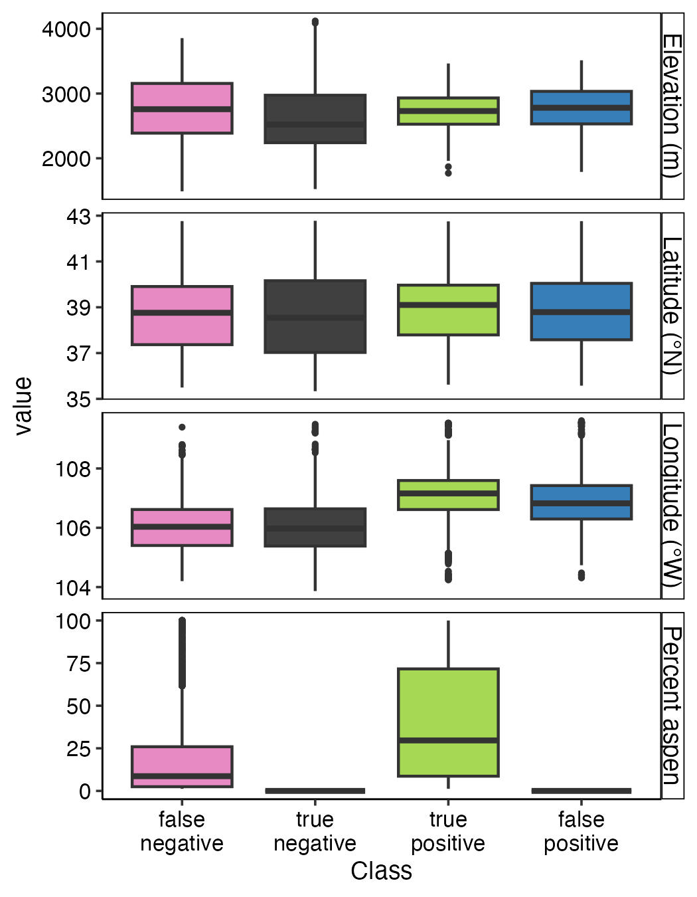

Figure 2: Boxplots illustrating the relationship between pixels misclassified and geographic variables and percent aspen cover.

## Effects of predictor variables on aspen habitat suitability

Across all models, variable importance scores revealed that climate variables contributed more to model fit than soil or topographic factors (Fig. 3A). Of the climate variables, PRATIO was on average the most important predictor, followed by ADI, GSPDD5, TD, and RH (Fig. 3A). Generally, aspen presence was negatively associated with PRATIO and positively associated GSPDD5 (Fig. 3B). Both ADI and TD were related to aspen presence following a more hump-shaped curve (Fig. 3B). For ADI, the highest probabilities of aspen presence occurred when ADI was between 0.04 and 0.06. For TD, aspen occurrence was most likely to occur when TD was between 20.6 and 21.7°C, although the GAM suggested a strong increase in the probability of aspen when TD exceeded 25°C, which rarely occurred across the study area. Of the topoedaphic factors, OM was the most important predictor, followed by TPI3, HLI, Clay, and SWC (Fig. 3A). Aspen presence was generally positively related to OM and negatively related to TPI3 (Fig. 3B).

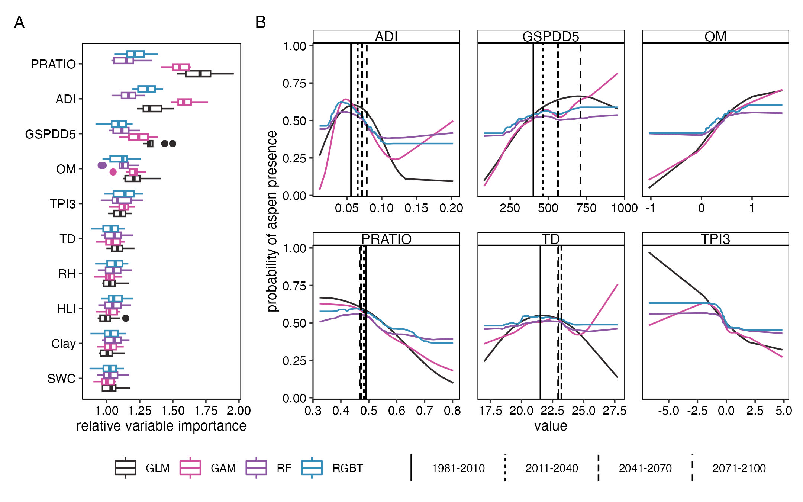

Figure 3: Variable importance scores (A) and accumulate local effects (B) for models of aspen habitat suitability by modeling approach. In A, boxes illustrate the loss in model performance (1-AUC) when the predictor variable was randomized for 10 different permutations. In B, vertical lines illustrate the mean climate conditions for areas with existing aspen for the historical period (1981-2010) and projections for the 2011-2040, 2041-2070, and 2071-2100 periods under the SSP5-8.5 scenario. For variable definitions and descriptions see Table 1.

## Forecasted change in the distribution of aspen

Our ensemble SDM suggests notable decreases in future aspen habit suitability across the SRM, particularly during the first half of the 21st century (Table 3). Relative to the 1981-2010 period, average aspen habitat suitability across the SRME for the 2011-2040 is forecasted to decrease by 8.4% under both the SSP2-4.5 and SSP5-8.5 scenarios. Low elevations are forecasted to experience particularly dramatic decreases in habitat suitability (Fig. 4).

Table 3: The ensemble mean habitat suitability for aspen across the study area by time period and scenario.

| scenario | years | mean |
| --- | --- | --- |
| historical | 1981-2010 | 0.394 |
| SSP2-4.5 | 2011-2040 | 0.310 |
| SSP2-4.5 | 2041-2070 | 0.330 |
| SSP2-4.5 | 2071-2100 | 0.330 |
| SSP5-8.5 | 2011-2040 | 0.310 |
| SSP5-8.5 | 2041-2070 | 0.330 |
| SSP5-8.5 | 2071-2100 | 0.350 |

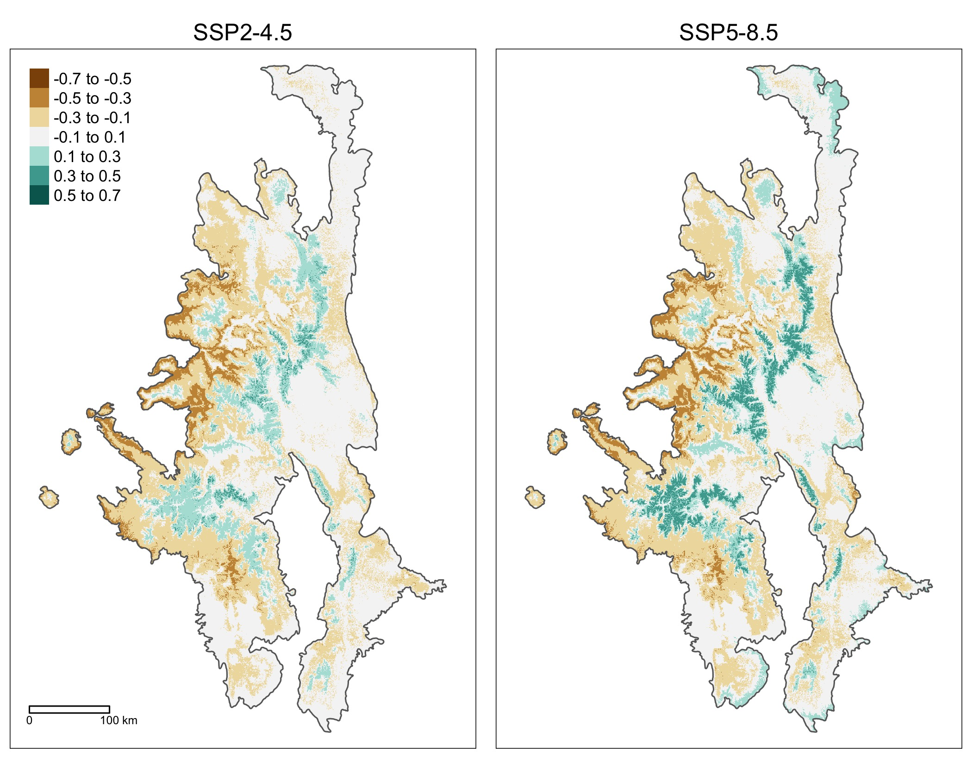

Figure 4: The forecasted change in aspen habitat suitability for the 2071-2100 period based on the SSP2-4.5 and SSP5-8.5 scenarios.

The decreases in suitability are forecasted to lead to the loss of suitable aspen habitat across 12091 km2 under the SSP2-4.5 scenario 12638 km2 under the SSP5-8.5 scenario) (Fig. 9). Notably, this loss includes an area of 6094 (SSP2-4.5) to 6746 (SSP5-8.5) km2 where aspen was present in 2019 (Fig. 9). These losses are expected to occur at lower elevations and eastern longitudes, where aspen is already limited (Fig. 5; 10).

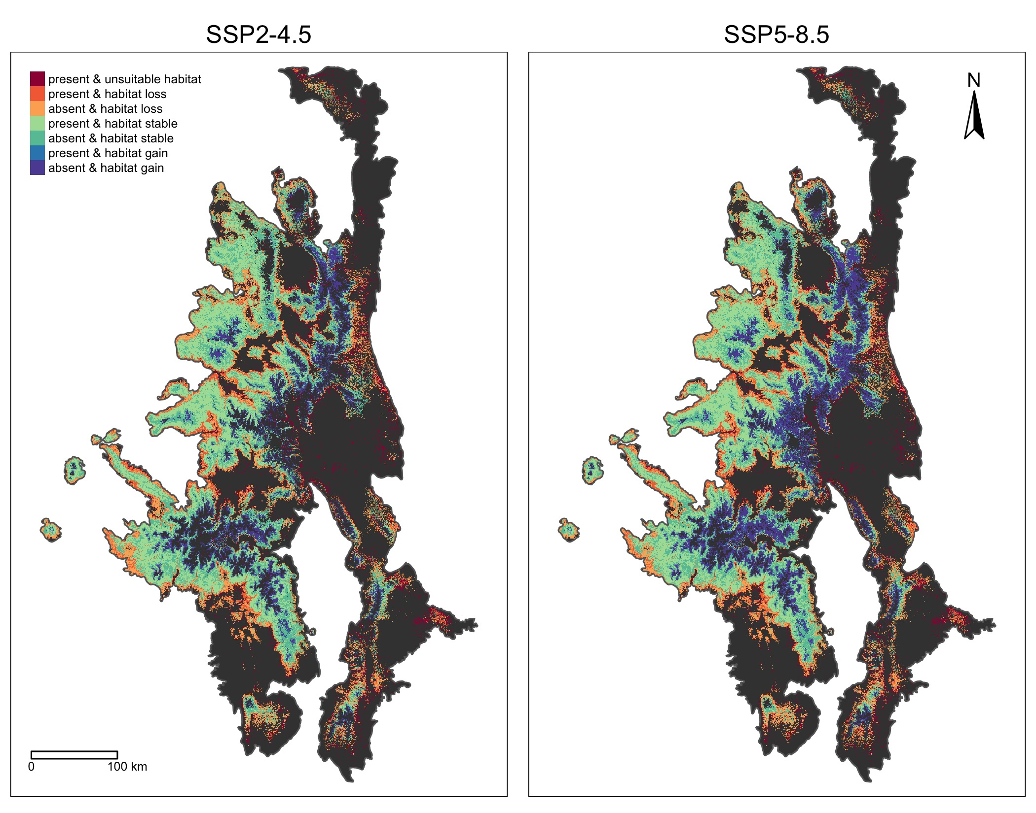

Figure 5: The distribution of pixels where the ensemble SDM forecasts aspen may be lost, gained, or stable by 2100 under the SSP2-4.5 and SSP5-8.5 scenarios.

The near-term losses in the area suitable for aspen may be offset by colonization of habitat currently suitable for aspen that is expected to remain suitable over the next century and/or increases in the areas suitable for aspen. Based on forecasted climate for the 2071-2100 period, 17071 (SSP2-4.5) to 16915 (SSP5-8.5) km2 where aspen is presently absent, but the habitat is suitable will remain suitable. Further, our ensemble model suggests that 7121 (SSP2-4.5) to 11725 (SSP5-8.5) km2 will become suitable for aspen by 2100. Across both scenarios and all time periods, increases in the area suitable for aspen are expected to occur at higher elevations (Figs. 10).

While the ensemble model suggests that the considerable area across the SRME will remain or become be suitable for aspen expansion over the next century, only a fraction of that area is near existing aspen stands (Fig. 6). Under the SSP4-2.5 scenario, 3% of the area forecasted to become suitable by 2071-2100 is within 90-m of existing aspen (Fig. 6), and 53% of the suitable area is within 540-m of existing aspen. Under the SSP5-8.5 scenario, 4% of the area forecasted to become suitable by 2071-2100 is within 90-m of existing aspen (Fig. 6), and 15% of the suitable area is within 540-m of existing aspen. Further, the potential for aspen expansion into areas that our model suggests are currently suitable may be even more limited by aspen’s current distribution. By 2071-2100, only 1% of the area forecasted to remain suitable is within 90-m of existing aspen (Fig. 6) and only 25% of the area forecasted to remain suitable is within 540-m of existing aspen.

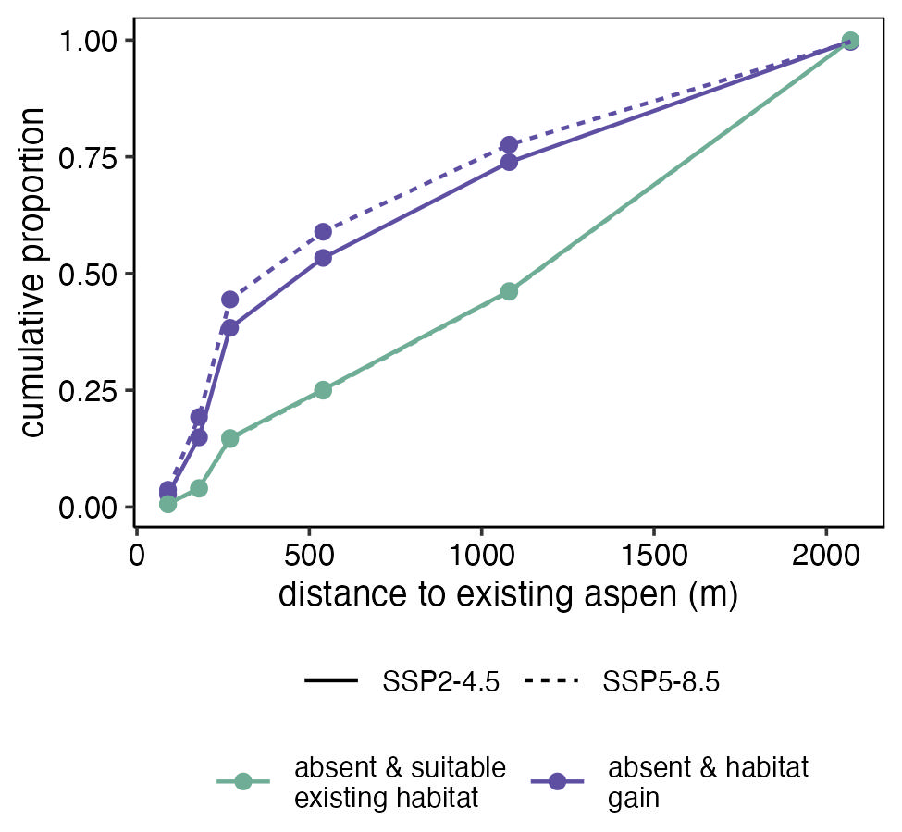

Figure 6: The distance to the nearest existing aspen patch for pixels where changes in climate may promote aspen expansion.

# Discussion

## Overview

This study combines high-resolution maps of the distribution of aspen, SDMs, and data from the most recent generation of climate models (CMIP6) to understand how climate change may influence aspen habitat suitability, the implications for existing aspen forest, and the potential for aspen expansion at high elevations. Using an ensemble modeling approach, we found that interactions between temperature and precipitation were important in constraining aspen’s distribution across the SRME and that future climate change will likely lead to widespread decreases in aspen habitat suitability across the region. While warming will likely increase habitat suitability at high elevations, we found that most of the area suitable for expansion is located more than 100 meters from existing aspen patches.

## Model performance

Here we accurately modeled the distribution of aspen across the SRME. Overall our ensemble model correctly predicted 79% of aspen presences and absences. While previous efforts to use SDMs to model the occurrence of aspen have reported lower error rates [e.g. <10%; Rehfeldt et al. (2009); Worrall et al. (2013)], we note that it is difficult to directly compare SDM performance when models differ in their spatial extent or grain, input data, and validation strategy. These challenges further emphasize the need for standardized methods that follow best practices for open-access science when building and sharing SDMs (Zurell et al., 2020).

In our ensemble SDM, most false negatives were located at more eastern latitudes, where aspen is generally present in lower abundance. Notably, these latitudes were also characterized by more abundant false positives in Cook et al.’s (2024) aspen map, which may help explain this pattern as the uncertainty in the map accuracy propagates to our models. In contrast, most false negatives were located at higher elevations and more western latitudes, likely due to biotic factors that our model does not include. Notably, in some habitats across the SRME, aspen regeneration is thought to occur episodically following severe stand-replacing fire, which removes competing conifers and stimulates vegetative reproduction (Kurzel et al., 2007). Across high elevation forests of the SRME, fires burn infrequently (Sherriff et al., 2001; Sibold and Veblen, 2006) and the century prior to Cook et al.’s (2024) aspen map (i.e., 1917-2018) was characterized by relatively little burning (Higuera et al., 2021). Thus at least some of the errors of commission may be due to disturbance and successional patterns, rather than abiotic cons

## Influences of climate, soil, and topography on aspen occurrence

Our SDMs show that aspen’s distribution across the SRME is strongly associated with interactions between temperature and precipitation. Aspen was notably absent from areas with long growing seasons and low annual precipitation (i.e., high ADI). In these locations, warm temperatures and low precipitation contribute to high atmospheric demand for moisture and low soil moisture. These conditions may limit carbohydrate production and cause hydraulic dysfunction thereby negatively impacting many demographic processes (Anderegg et al., 2013). For many trees across the SRME, the negative effects of summer aridity may be moderated by snow, which may provide trees with the necessary soil moisture to sustain growth late into the summer (Hu et al., 2010). Here we found that aspen was mostly likely to occur in areas where most precipitation fell during the cooler months (i.e. PRATIO < 0.5), consistent with previous research (Rehfeldt et al., 2009). While low moisture availability due to warm temperatures and low winter precipitation may limit the distribution of aspen, our model also suggests that aspen is unlikely to occur in habitats where extremely low temperatures result in a very short growing season. Such conditions are well established to limit many tree physiological and demographic processes (Tranquillini, 1979; Way and Oren, 2010), particularly when combined with low growing season precipitation (i.e., low GSPDD5) (Rehfeldt et al., 2009).

The topoedaphic factors included in our SDM also highlight the role of moisture availability in shaping aspen’s distribution across the SRME. Aspen occurrence was positively associated soils with higher organic matter content, which may promote soil moisture retention (Perala, 1990). Similarly, aspen was more likely to occur in valley bottoms and on benches than steep slopes (i.e., high TPI3), where overland and subsurface flow may cause more rapid drying of soils (Jones and DeByle, 1985). The importance of these topoedaphic factors even after including topographically downscaled climate variables, highlights the important role that landscape heterogeneity will likely play in determining how species respond to climate change.

## The future for aspen

Our modeling suggests that future changes in climate are likely to dramatically alter aspen habitat suitability across the SRM, consistent with previous research (Greer et al., 2016; Rehfeldt et al., 2015; Worrall et al., 2013). Interestingly, we found that near-term climate conditions (2011-2040), will cause the most dramatic decrease in the area suitable for aspen. This near-term decrease is expected to occur primarily as a result of increases in ADI. On average ADI during the 2011-2040 period is forecasted decrease by 16% relative to the 1981-2010. This decrease in aspen habitat suitability over the near term corresponds with observations of sudden aspen decline that occurred concurrently with drought events during the early 21st century (Anderegg et al., 2013; Worrall et al., 2007). Our research adds to a growing body of literature that highlights the potential for future increases in aridity and the frequency and severity of droughts to drive significant change in forest ecosystems (Allen et al., 2010; Andrus et al., 2021; Hammond et al., 2022; Smith et al., 2015; Williams et al., 2012).

While there are large areas that are currently suitable for aspen will likely become unsuitable, our ensemble model also suggests that there are extensive areas where the climate may be suitable for aspen expansion over the 21st century. However, nearly all of the area suitable for aspen expansion is located more than 90 m from existing mature live aspen. Because most aspen regeneration occurs clonally through root suckering (DeByle and Winokur, 1985) and the lateral roots of aspen that produce new suckers generally extend less than 30 m from the adult tree (DeByle and Winokur, 1985), natural expansion into these areas may be limited. Instead, expansion into these areas may depend upon establishment from seed or artificial regeneration practices.

The potential for aspen to colonize new areas through aspen seedling recruitment will depend on several factors. Aspen produce abundant light-weight seeds that can be transported several kilometers by strong winds (Landhäusser et al., 2019; Turner et al., 2003), but most seedling establishment occurs near live adult trees (Gill et al., 2017b; Kreider and Yocom, 2021). Thus like the limited potential for vegetative reproduction, natural regeneration from seed will be restricted to the narrow area with suitable habitat that is nearby existing aspen. Given seed arrives, germination will only occur on moist substrates, which are often located within microdepressions where water collects or near coarse woody debris that provides shade (Carter et al., 2024; Kreider and Yocom, 2021). In addition to moisture, germinants require partial or direct sunlight to survive because aspen seeds lack an endosperm (Landhäusser et al., 2019). Thus seedling establishment is far more likely to occur at sites that were recently burned or harvested, where competition for light is limited (McIlroy and Shinneman, 2020). While the root systems of young seedlings are developing and capable of accessing water close to the soil surface they are highly vulnerable to drought (Landhäusser et al., 2019). Finally, recruitment into the canopy is often limited by herbivory because aspen are a favored food of many ungulates, and continued browsing can severely limit aspen height growth (Ripple and Larsen, 2000; Romme et al., 1995). While these filters are generally well understood, more research is necessary to understand when and where aspen seedling establishment will result in mature aspen forest (Gill et al., 2017a), particularly in the Southern Rocky Mountains.

Out-planting of nursery grown seedlings or suckers can bypass some of the filters that limit natural regeneration from seed. Nursery practices that enhance resilience to drought can result in more successful plantings (Sloan et al., 2020). For instance, nursery practices that increase non-structural carbohydrate reserves and root:shoot ratios have the potential to increase growth rates of seedlings in field experiments [(Landhäusser et al., 2012a; Landhäusser et al., 2012b; Sloan et al., 2020). More research is needed to understand how nursery practices may be used to manipulate the morphological and physiological traits of seedlings and the implications for out-planting performance, which has received relatively little study relative to more commercially viable conifer species (Landhäusser et al., 2019).

# Conclusions

Climate change presents considerable threats to forest ecosystems and challenges for forest managers (Keenan, 2015). By combining a SDM with fine-grain maps of aspen’s current distribution, we provide a novel assessment of how climate change may influence existing aspen stands and where might be suitable for future expansion - insights that are key for effective management. Our modeling shows that future warming is likely to considerably decrease aspen habitat suitability across the SRME, particularly for populations at low elevations. Nonetheless, considerable area will remain or become suitable for aspen. However, areas suitable for expansion are typically not adjacent to existing stands, thereby limiting colonization of these areas to natural regeneration from seed or artificial regeneration through direct seeding or planting. Yet, we still know very little about the role of seedling establishment or how genetic factors, nursery practices, and planting approaches influence the outcomes of artificial regeneration (Landhäusser et al., 2019).

# Acknowledgements

The Southern Rocky Mountains are the sacred homelands to many Indigenous nations – we honor their past, present, and future generations, who have lived here and stewarded these forests for millennia.This research was funded by the Joint Fire Science Program (JFSP, Project ID 21-2-02-29).

# Author contributions: CRediT

**Sarah J. Hart:** Conceptualization, Funding acquisition, Methodology, Formal analysis, Writing- Original draft preparation, Writing – review and editing; **Asha Paudel**: Writing – review and editing, Methodology. **Maxwell C. Cook**: Funding acquisition, Writing – review and editing;

# Data availability

All code used in this paper are available in a public GitHub repository (link). Maps of the predicted habitat suitability area available through Dryad via the following anonymized link: [http://datadryad.org/stash/share/gGubdiD6hCORznmbeHB6gkWoxodyj25Soa3s3yfOfHg](https://nam10.safelinks.protection.outlook.com/?url=http%3A%2F%2Fdatadryad.org%2Fstash%2Fshare%2FgGubdiD6hCORznmbeHB6gkWoxodyj25Soa3s3yfOfHg&data=05%7C02%7Csarah.hart%40colostate.edu%7Cc00ff4ef23d4486ecd8e08dceee39cf4%7Cafb58802ff7a4bb1ab21367ff2ecfc8b%7C0%7C0%7C638647908580903395%7CUnknown%7CTWFpbGZsb3d8eyJWIjoiMC4wLjAwMDAiLCJQIjoiV2luMzIiLCJBTiI6Ik1haWwiLCJXVCI6Mn0%3D%7C0%7C%7C%7C&sdata=i%2B45VPN9dbfLKYiR0rbKPxa%2BoWV6Kc%2BHP8v%2FlumACRM%3D&reserved=0).

# References

AdaptWest Project, 2022. [Gridded current and projected climate data for north america at 1km resolution, generated using the ClimateNA v7.30 software (t. Wang et al., 2022).](https://Available at adaptwest.databasin.org.)

Allen, C.D., Macalady, A.K., Chenchouni, H., Bachelet, D., McDowell, N., Vennetier, M., Kitzberger, T., Rigling, A., Breshears, D.D., Hogg, E.H., 2010. A global overview of drought and heat-induced tree mortality reveals emerging climate change risks for forests. Forest Ecology and Management 259, 660–684. <https://doi.org/10.1016/j.foreco.2009.09.001>

Anderegg, L.D.L., Anderegg, W.R.L., Abatzoglou, J., Hausladen, A.M., Berry, J.A., 2013. Drought characteristics’ role in widespread aspen forest mortality across Colorado, USA. Global Change Biology 19, 1526–1537. <https://doi.org/10.1111/gcb.12146>

Andrus, R.A., Chai, R.K., Harvey, B.J., Rodman, K.C., Veblen, T.T., 2021. Increasing rates of subalpine tree mortality linked to warmer and drier summers. Journal of Ecology 109, 2203–2218. <https://doi.org/10.1111/1365-2745.13634>

Andrus, R.A., Hart, S.J., Veblen, T.T., 2020. Forest recovery following synchronous outbreaks of spruce and western balsam bark beetle is slowed by ungulate browsing. Ecology 101, e02998. <https://doi.org/10.1002/ecy.2998>

Apley, D., 2018. [ALEPlot: Accumulated local effects (ALE) plots and partial dependence (PD) plots](https://CRAN.R-project.org/package=ALEPlot).

Apley, D.W., Zhu, J., 2020. Visualizing the effects of predictor variables in black box supervised learning models. Journal of the Royal Statistical Society: Series B (Statistical Methodology) 82, 1059–1086. <https://doi.org/10.1111/rssb.12377>

Araujo, M., New, M., 2007. Ensemble forecasting of species distributions. Trends in Ecology & Evolution 22, 42–47. <https://doi.org/10.1016/j.tree.2006.09.010>

Araújo, M.B., Anderson, R.P., Márcia Barbosa, A., Beale, C.M., Dormann, C.F., Early, R., Garcia, R.A., Guisan, A., Maiorano, L., Naimi, B., O’Hara, R.B., Zimmermann, N.E., Rahbek, C., 2019. Standards for distribution models in biodiversity assessments. Science Advances 5, eaat4858. <https://doi.org/10.1126/sciadv.aat4858>

Baker, W.L., Veblen, T.T., 1990. Spruce beetles and fires in the nineteenth-century subalpine forests of western colorado, USA. Arctic and Alpine Research 22, 6580.

Biecek, P., 2018. [DALEX: Explainers for complex predictive models in r](https://jmlr.org/papers/v19/18-416.html) 19, 1–5.

Breiman, L., Friedman, J.H., Olshen, R.A., Stone, C.G., 1984. Classification and regression trees. Belmont, CA, USA. <https://doi.org/10.1201/9781315139470>

Campbell, R.B., Bartos, D.L., 2001. Aspen ecosystems: Objectives for sustaining biodiversity. p. 299307.

Carter, S., Hart, S., Rhoades, C., Rocca, M., 2024. [Occurrence, distribution, and driving environmental factors of quaking aspen regeneration by seed in the cameron peak fire burn scar](https://api.mountainscholar.org/server/api/core/bitstreams/14cc73e5-8e74-42f2-b414-45e877ef91c0/content).

Chaney, N.W., Minasny, B., Herman, J.D., Nauman, T.W., Brungard, C.W., Morgan, C.L.S., McBratney, A.B., Wood, E.F., Yimam, Y., 2019. POLARIS Soil Properties: 30-m Probabilistic Maps of Soil Properties Over the Contiguous United States. Water Resources Research 55, 2916–2938. <https://doi.org/10.1029/2018WR022797>

Chapman, T.B., Veblen, T.T., Schoennagel, T., 2012. Spatiotemporal patterns of mountain pine beetle activity in the southern rocky mountains. Ecology 93, 2175–2185. <https://doi.org/10.1890/11-1055.1>

Chen, T., He, T., Benesty, M., Khotilovich, V., Tang, Y., Cho, H., Chen, K., Mitchell, R., Cano, I., Zhou, T., Li, M., Xie, J., Lin, M., Geng, Y., Li, Y., Yuan, J., 2023. [Xgboost: Extreme gradient boosting](https://CRAN.R-project.org/package=xgboost).

Comer, P., 2001. Southern rocky mountains: An ecoregional assessment and conservation blueprint.

Cook, M., Chapman, T., Hart, S., Paudel, A., Balch, J., 2024. Mapping Quaking Aspen Using Seasonal Sentinel-1 and Sentinel-2 Composite Imagery across the Southern Rockies, USA. Remote Sensing 16, 1619. <https://doi.org/10.3390/rs16091619>

Cutler, D.R., Edwards Jr, T.C., Beard, K.H., Cutler, A., Hess, K.T., Gibson, J., Lawler, J.J., 2007. Random forests for classification in ecology. Ecology 88, 27832792.

De’ath, G., 2007. Boosted Trees for Ecological Modeling and Prediction. Ecology 88, 243–251. <https://doi.org/10.1890/0012-9658(2007)88[243:BTFEMA]2.0.CO;2>

Death, G., Fabricius, K.E., 2000. [Classification and regression trees: A powerful yet simple technique for ecological data analysis](http://www.esajournals.org/doi/pdf/10.1890/0012-9658(2000)081%5B3178:CARTAP%5D2.0.CO%3B2). Ecology 81, 31783192.

DeByle, N.V., Winokur, R.P., 1985. Aspen: Ecology and management in the western United States. Ft. Collins, CO. <https://doi.org/10.2737/RM-GTR-119>

Drummond, M.A., 2012. [Southern rockies ecoregion: Chapter 8 in status and trends of land change in the western united states–1973 to 2000](http://pubs.er.usgs.gov/publication/pp1794A8). Reston, VA.

Ehrlén, J., Morris, W.F., 2015. Predicting changes in the distribution and abundance of species under environmental change. Ecology Letters 18, 303–314. <https://doi.org/10.1111/ele.12410>

Elith, J., Leathwick, J.R., 2009. Species Distribution Models: Ecological Explanation and Prediction Across Space and Time. Annual Review of Ecology, Evolution, and Systematics 40, 677–697. <https://doi.org/10.1146/annurev.ecolsys.110308.120159>

Evans, J.S., Murphy, M.A., 2021. [spatialEco](https://github.com/jeffreyevans/spatialEco).

Flint, L.E., Flint, A.L., 2012. Downscaling future climate scenarios to fine scales for hydrologic and ecological modeling and analysis. Ecological Processes 1, 2. <https://doi.org/10.1186/2192-1709-1-2>

Franklin, J., Davis, F.W., Ikegami, M., Syphard, A.D., Flint, L.E., Flint, A.L., Hannah, L., 2013. Modeling plant species distributions under future climates: how fine scale do climate projections need to be? Global Change Biology 19, 473–483. <https://doi.org/10.1111/gcb.12051>

Friedman, J.H., 2001. [Greedy function approximation: A gradient boosting machine](https://www.jstor.org/stable/2699986). The Annals of Statistics 29, 1189–1232.

Friedman, J., Tibshirani, R., Hastie, T., 2010. Regularization paths for generalized linear models via coordinate descent 33. <https://doi.org/10.18637/jss.v033.i01>

Gill, N.S., Jarvis, D., Veblen, T.T., Pickett, S.T.A., Kulakowski, D., 2017a. Is initial post-disturbance regeneration indicative of longer-term trajectories? Ecosphere 8, e01924. <https://doi.org/10.1002/ecs2.1924>

Gill, N.S., Sangermano, F., Buma, B., Kulakowski, D., 2017b. *Populus tremuloides* seedling establishment: An underexplored vector for forest type conversion after multiple disturbances. Forest Ecology and Management 404, 156–164. <https://doi.org/10.1016/j.foreco.2017.08.008>

Graae, B.J., Vandvik, V., Armbruster, W.S., Eiserhardt, W.L., Svenning, J.-C., Hylander, K., Ehrlén, J., Speed, J.D.M., Klanderud, K., Bråthen, K.A., Milbau, A., Opedal, Ø.H., Alsos, I.G., Ejrnæs, R., Bruun, H.H., Birks, H.J.B., Westergaard, K.B., Birks, H.H., Lenoir, J., 2018. Stay or go how topographic complexity influences alpine plant population and community responses to climate change. Perspectives in Plant Ecology, Evolution and Systematics, Special issue on alpine and arctic plant communities : A worldwide perspective 30, 41–50. <https://doi.org/10.1016/j.ppees.2017.09.008>

Greer, B.T., Still, C., Howe, G.T., Tague, C., Roberts, D.A., 2016. Populations of aspen (populus tremuloides michx.) with different evolutionary histories differ in their climate occupancy. Ecology and Evolution 6, 3032–3039. <https://doi.org/10.1002/ece3.2102>

Hammond, W.M., Williams, A.P., Abatzoglou, J.T., Adams, H.D., Klein, T., López, R., Sáenz-Romero, C., Hartmann, H., Breshears, D.D., Allen, C.D., 2022. Global field observations of tree die-off reveal hotter-drought fingerprint for Earth’s forests. Nature Communications 13, 1761. <https://doi.org/10.1038/s41467-022-29289-2>

Hanna, P., Kulakowski, D., 2012. [The influences of climate on aspen dieback](http://www.sciencedirect.com/science/article/pii/S0378112712000783). Forest Ecology and Management 274, 9198.

Hart, S.J., Veblen, T.T., Eisenhart, K.S., Jarvis, D., Kulakowski, D., 2014. Drought induces spruce beetle (dendroctonus rufipennis) outbreaks across northwestern colorado. Ecology 95, 930939.

Hastie, T., Tibshirani, R., Friedman, J.H., Friedman, J.H., 2009. The elements of statistical learning: Data mining, inference, and prediction. Springer.

He, K.S., Bradley, B.A., Cord, A.F., Rocchini, D., Tuanmu, M.-N., Schmidtlein, S., Turner, W., Wegmann, M., Pettorelli, N., 2015. Will remote sensing shape the next generation of species distribution models? Remote Sensing in Ecology and Conservation 1, 4–18. <https://doi.org/10.1002/rse2.7>

Higuera, P.E., Shuman, B.N., Wolf, K.D., 2021. Rocky Mountain subalpine forests now burning more than any time in recent millennia. Proceedings of the National Academy of Sciences 118. <https://doi.org/10.1073/pnas.2103135118>

Hu, J., Moore, D.J.P., Burns, S.P., Monson, R.K., 2010. Longer growing seasons lead to less carbon sequestration by a subalpine forest. Global Change Biology 16, 771–783. <https://doi.org/10.1111/j.1365-2486.2009.01967.x>

Jones, J.R., DeByle, N.V., 1985. [Soils](https://www.fs.usda.gov/research/treesearch/27780). In: DeByle, Norbert V.; Winokur, Robert P., editors. Aspen: Ecology and management in the western United States. USDA Forest Service General Technical Report RM-119. Rocky Mountain Forest and Range Experiment Station, Fort Collins, Colo. p. 65-70 119.

Keenan, R.J., 2015. Climate change impacts and adaptation in forest management: a review. Annals of Forest Science 72, 145–167. <https://doi.org/10.1007/s13595-014-0446-5>

Kreider, M.R., Yocom, L.L., 2021. Aspen seedling establishment, survival, and growth following a high-severity wildfire. Forest Ecology and Management 493, 119248. <https://doi.org/10.1016/j.foreco.2021.119248>

Kuhn, M., Vaughan, D., Ruiz, E., 2023. [Probably: Tools for post-processing class probability estimates](https://CRAN.R-project.org/package=probably).

Kuhn, M., Wickham, H., 2020. [Tidymodels: A collection of packages for modeling and machine learning using tidyverse principles.](https://www.tidymodels.org)

Kurzel, B.P., Veblen, T.T., Kulakowski, D., 2007. A typology of stand structure and dynamics of Quaking aspen in northwestern Colorado. Forest Ecology and Management 252, 176–190. <https://doi.org/10.1016/j.foreco.2007.06.027>

Kusch, E., Davy, R., 2022. KrigRa tool for downloading and statistically downscaling climate reanalysis data. Environmental Research Letters 17, 024005. <https://doi.org/10.1088/1748-9326/ac48b3>

Landhäusser, S.M., Pinno, B.D., Lieffers, V.J., Chow, P.S., 2012a. Partitioning of carbon allocation to reserves or growth determines future performance of aspen seedlings. Forest Ecology and Management 275, 43–51. <https://doi.org/10.1016/j.foreco.2012.03.010>

Landhäusser, S.M., Pinno, B.D., Mock, K.E., 2019. Tamm Review: Seedling-based ecology, management, and restoration in aspen (Populus tremuloides). Forest Ecology and Management 432, 231–245. <https://doi.org/10.1016/j.foreco.2018.09.024>

Landhäusser, S.M., Rodriguez-Alvarez, J., Marenholtz, E.H., Lieffers, V.J., 2012b. Effect of stock type characteristics and time of planting on field performance of aspen (Populus tremuloides Michx.) seedlings on boreal reclamation sites. New Forests 43, 679–693. <https://doi.org/10.1007/s11056-012-9346-4>

Lukas, J., Barsugli, J., Doesken, N., Rangwala, I., Wolter, K., 2014. Climate change in colorado: A synthesis to support water resources management and adaptation. University of Colorado, Boulder, Colorado.

Mahoney, M.J., Johnson, L.K., Silge, J., Frick, H., Kuhn, M., Beier, C.M., 2023. Assessing the performance of spatial cross-validation approaches for models of spatially structured data. <https://doi.org/10.48550/arXiv.2303.07334>

Mahony, C.R., Wang, T., Hamann, A., Cannon, A.J., 2022. A global climate model ensemble for downscaled monthly climate normals over North America. International Journal of Climatology 42, 5871–5891. <https://doi.org/10.1002/joc.7566>

Malanson, G.P., Cairns, D.M., 1997. Effects of dispersal, population delays, and forest fragmentation on tree migration rates. Plant Ecology 131, 67–79. <https://doi.org/10.1023/A:1009770924942>

McCune, B., 2007. [Improved estimates of incident radiation and heat load using non-parametric regression against topographic variables](https://www.jstor.org/stable/4499284). Journal of Vegetation Science 18, 751–754.

McCune, B., Keon, D., 2002. [Equations for potential annual direct incident radiation and heat load](https://www.jstor.org/stable/3236745). Journal of Vegetation Science 13, 603–606.

McIlroy, S.K., Shinneman, D.J., 2020. Post-fire aspen (Populus tremuloides) regeneration varies in response to winter precipitation across a regional climate gradient. Forest Ecology and Management 455, 117681. <https://doi.org/10.1016/j.foreco.2019.117681>

Mitton, J.B., Grant, M.C., 1996. Genetic variation and the natural history of quaking aspen. BioScience 46, 25–31. <https://doi.org/10.2307/1312652>

Nalder, I.A., Wein, R.W., 1998. Spatial interpolation of climatic Normals: test of a new method in the Canadian boreal forest. Agricultural and Forest Meteorology 92, 211–225. <https://doi.org/10.1016/S0168-1923(98)00102-6>

Nigro, K.M., Rocca, M.E., Battaglia, M.A., Coop, J.D., Redmond, M.D., 2022. Wildfire catalyzes upward range expansion of trembling aspen in southern Rocky Mountain beetle-killed forests. Journal of Biogeography 49, 201–214. <https://doi.org/10.1111/jbi.14302>

Parmesan, C., Yohe, G., 2003. A globally coherent fingerprint of climate change impacts across natural systems. Nature 421, 37–42. <https://doi.org/10.1038/nature01286>

Pedersen, E.J., Miller, D.L., Simpson, G.L., Ross, N., 2018. Hierarchical generalized additive models: an introduction with mgcv. <https://doi.org/10.7287/peerj.preprints.27320v1>

Peet, R.K., 1981. Forest vegetation of the colorado front range. Vegetatio 45, 375.

Pepin, N., Bradley, R.S., Diaz, H.F., Baraer, M., Caceres, E.B., Forsythe, N., Fowler, H., Greenwood, G., Hashmi, M.Z., Liu, X.D., Miller, J.R., Ning, L., Ohmura, A., Palazzi, E., Rangwala, I., Schöner, W., Severskiy, I., Shahgedanova, M., Wang, M.B., Williamson, S.N., Yang, D.Q., Mountain Research Initiative EDW Working Group, 2015. Elevation-dependent warming in mountain regions of the world. Nature Climate Change 5, 424–430. <https://doi.org/10.1038/nclimate2563>

Perala, D., 1990. [Populus tremuloides michx. Quaking aspen](https://digitalcommons.usu.edu/aspen_bib/2878). U.S. Department of Agriculture, Forest Service. Washington, DC 555–569.

Powers, S.M., Hampton, S.E., 2019. Open science, reproducibility, and transparency in ecology. Ecological Applications 29, e01822. <https://doi.org/10.1002/eap.1822>

PRISM Climate Group, 2021. [Monthly 30-year climate normals (1981-2010)](https://prism.oregonstate.edu/normals/).

R Core Team, 2022. [R: A language and environment for statistical computing](http://www.R-project.org). R Foundation for Statistical Computing, Vienna, Austria.

Randin, C.F., Ashcroft, M.B., Bolliger, J., Cavender-Bares, J., Coops, N.C., Dullinger, S., Dirnböck, T., Eckert, S., Ellis, E., Fernández, N., Giuliani, G., Guisan, A., Jetz, W., Joost, S., Karger, D., Lembrechts, J., Lenoir, J., Luoto, M., Morin, X., Price, B., Rocchini, D., Schaepman, M., Schmid, B., Verburg, P., Wilson, A., Woodcock, P., Yoccoz, N., Payne, D., 2020. Monitoring biodiversity in the Anthropocene using remote sensing in species distribution models. Remote Sensing of Environment 239, 111626. <https://doi.org/10.1016/j.rse.2019.111626>

Rehfeldt, G.E., Crookston, N.L., Warwell, M.V., Evans, J.S., 2006. Empirical analyses of plant-climate relationships for the western united states. International Journal of Plant Sciences 167, 11231150.

Rehfeldt, G.E., Ferguson, D.E., Crookston, N.L., 2009. Aspen, climate, and sudden decline in western USA. Forest Ecology and Management 258, 2353–2364. <https://doi.org/10.1016/j.foreco.2009.06.005>

Rehfeldt, G.E., Worrall, J.J., Marchetti, S.B., Crookston, N.L., 2015. Adapting forest management to climate change using bioclimate models with topographic drivers. Forestry. doi: 10.1093/forestry/cpv019. <https://doi.org/10.1093/forestry/cpv019>

Riahi, K., Vuuren, D.P. van, Kriegler, E., Edmonds, J., O’Neill, B.C., Fujimori, S., Bauer, N., Calvin, K., Dellink, R., Fricko, O., Lutz, W., Popp, A., Cuaresma, J.C., Kc, S., Leimbach, M., Jiang, L., Kram, T., Rao, S., Emmerling, J., Ebi, K., Hasegawa, T., Havlik, P., Humpenöder, F., Da Silva, L.A., Smith, S., Stehfest, E., Bosetti, V., Eom, J., Gernaat, D., Masui, T., Rogelj, J., Strefler, J., Drouet, L., Krey, V., Luderer, G., Harmsen, M., Takahashi, K., Baumstark, L., Doelman, J.C., Kainuma, M., Klimont, Z., Marangoni, G., Lotze-Campen, H., Obersteiner, M., Tabeau, A., Tavoni, M., 2017. The shared socioeconomic pathways and their energy, land use, and greenhouse gas emissions implications: An overview. Global Environmental Change 42, 153–168. <https://doi.org/10.1016/j.gloenvcha.2016.05.009>

Ripple, W.J., Larsen, E.J., 2000. Historic aspen recruitment, elk, and wolves in northern Yellowstone National Park, USA. Biological Conservation 95, 361–370. <https://doi.org/10.1016/S0006-3207(00)00014-8>

Rodman, K.C., Andrus, R.A., Butkiewicz, C.L., Chapman, T.B., Gill, N.S., Harvey, B.J., Kulakowski, D., Tutland, N.J., Veblen, T.T., Hart, S.J., 2021. Effects of bark beetle outbreaks on forest landscape pattern in the Southern Rocky Mountains, U.S.A. Remote Sensing 13, 1089. <https://doi.org/10.3390/rs13061089>

Rodman, K.C., Veblen, T.T., Battaglia, M.A., Chambers, M.E., Fornwalt, P.J., Holden, Z.A., Kolb, T.E., Ouzts, J.R., Rother, M.T., 2020. A changing climate is snuffing out post-fire recovery in montane forests. Global Ecology and Biogeography geb.13174. <https://doi.org/10.1111/geb.13174>

Rogers, P.C., Pinno, B.D., Šebesta, J., Albrectsen, B.R., Li, G., Ivanova, N., Kusbach, A., Kuuluvainen, T., Landhäusser, S.M., Liu, H., Myking, T., Pulkkinen, P., Wen, Z., Kulakowski, D., 2020. A global view of aspen: Conservation science for widespread keystone systems. Global Ecology and Conservation 21, e00828. <https://doi.org/10.1016/j.gecco.2019.e00828>

Romme, W.H., Turner, M.G., Wallace, L.L., Walker, J.S., 1995. Aspen, Elk, and Fire in Northern Yellowstone Park. Ecology 76, 2097–2106. <https://doi.org/10.2307/1941684>

Seo, C., Thorne, J.H., Hannah, L., Thuiller, W., 2008. Scale effects in species distribution models: Implications for conservation planning under climate change. Biology Letters 5, 39–43. <https://doi.org/10.1098/rsbl.2008.0476>

Sherriff, R.L., Veblen, T., Sibold, J., 2001. Fire history in high elevation subalpine forests in the Colorado Front Range. Écoscience 8, 369–380. <https://doi.org/10.1080/11956860.2001.11682665>

Sibold, J.S., Veblen, T.T., 2006. Relationships of subalpine forest fires in the colorado front range with interannual and multidecadal-scale climatic variation. Journal of Biogeography 33, 833–842. <https://doi.org/10.1111/j.1365-2699.2006.01456.x>

Sloan, J.L., Burney, O.T., Pinto, J.R., 2020. Drought-conditioning of quaking aspen (populus tremuloides michx.) seedlings during nursery production modifies seedling anatomy and physiology. Frontiers in Plant Science 11. <https://doi.org/10.3389/fpls.2020.557894>

Smith, J.M., Paritsis, J., Veblen, T.T., Chapman, T.B., 2015. Permanent forest plots show accelerating tree mortality in subalpine forests of the colorado front range from 1982 to 2013. Forest Ecology and Management 341, 8–17. <https://doi.org/10.1016/j.foreco.2014.12.031>

Tranquillini, W., 1979. Growth of Trees at Timberline, in: Tranquillini, W. (Ed.),. Springer, Berlin, Heidelberg, pp. 19–38. <https://doi.org/10.1007/978-3-642-67107-4_5>

Turner, M.G., Romme, W.H., Reed, R.A., Tuskan, G.A., 2003. Post-fire aspen seedling recruitment across the Yellowstone (USA) Landscape. Landscape Ecology 18, 127–140. <https://doi.org/10.1023/A:1024462501689>

U. S. Geological Survey, 2023. [USGS 3D elevation program digital elevation model](https://elevation.nationalmap.gov/arcgis/rest/services/3DEPElevation/ImageServer.).

Veblen, T.T., Hadley, K.S., Nel, E.M., Kitzberger, T., Reid, M., Villalba, R., 1994. Disturbance regime and disturbance interactions in a rocky mountain subalpine forest. Journal of Ecology 82, 125–135. <https://doi.org/10.2307/2261392>

Veblen, T.T., Kitzberger, T., Donnegan, J., 2000. Climatic and Human Influences on Fire Regimes in Ponderosa Pine Forests in the Colorado Front Range. Ecological Applications 10, 1178–1195. https://doi.org/<https://doi.org/10.1890/1051-0761(2000)010[1178:CAHIOF]2.0.CO;2>

Wang, T., Hamann, A., Spittlehouse, D., Carroll, C., 2016. Locally Downscaled and Spatially Customizable Climate Data for Historical and Future Periods for North America. PLOS ONE 11, e0156720. <https://doi.org/10.1371/journal.pone.0156720>

Way, D.A., Oren, R., 2010. Differential responses to changes in growth temperature between trees from different functional groups and biomes: A review and synthesis of data. Tree Physiology 30, 669–688. <https://doi.org/10.1093/treephys/tpq015>

Weiss, A., 2001. Topographic position and landforms analysis.

Williams, A.P., Allen, C.D., Macalady, A.K., Griffin, D., Woodhouse, C.A., Meko, D.M., Swetnam, T.W., Rauscher, S.A., Seager, R., Grissino-Mayer, H.D., Dean, J.S., Cook, E.R., Gangodagamage, C., Cai, M., McDowell, N.G., 2012. Temperature as a potent driver of regional forest drought stress and tree mortality. Nature Climate Change 3, 292297. <https://doi.org/10.1038/nclimate1693>

Wood, S.N., 2011. Fast stable restricted maximum likelihood and marginal likelihood estimation of semiparametric generalized linear models 73, 3–36.

Worrall, J., Egeland, L., Eager, T., Mask, R., Johnson, E., Kemp, P., Shepperd, W., 2007. Sudden aspen decline in southwest Colorado: site and stand factors and a hypothesis on etiology 4.

Worrall, J.J., Rehfeldt, G.E., Hamann, A., Hogg, E.H., Marchetti, S.B., Michaelian, M., Gray, L.K., 2013. Recent declines of Populus tremuloides in North America linked to climate. Forest Ecology and Management 299, 35–51. <https://doi.org/10.1016/j.foreco.2012.12.033>

Wright, M.N., Ziegler, A., 2017a. Ranger: A fast implementation of random forests for high dimensional data in c++ and r 77. <https://doi.org/10.18637/jss.v077.i01>

Wright, M.N., Ziegler, A., 2017b. Ranger: A fast implementation of random forests for high dimensional data in c++ and r 77. <https://doi.org/10.18637/jss.v077.i01>

Yackulic, C.B., Chandler, R., Zipkin, E.F., Royle, J.A., Nichols, J.D., Campbell Grant, E.H., Veran, S., 2013. Presence-only modelling using MAXENT : when can we trust the inferences? Methods in Ecology and Evolution 4, 236–243. <https://doi.org/10.1111/2041-210x.12004>

Youden, W.J., 1950. Index for rating diagnostic tests. Cancer 3, 32–35. <https://doi.org/10.1002/1097-0142(1950)3:1<32::AID-CNCR2820030106>3.0.CO;2-3>

Zurell, D., Franklin, J., König, C., Bouchet, P.J., Dormann, C.F., Elith, J., Fandos, G., Feng, X., Guillera-Arroita, G., Guisan, A., Lahoz-Monfort, J.J., Leitão, P.J., Park, D.S., Peterson, A.T., Rapacciuolo, G., Schmatz, D.R., Schröder, B., Serra-Diaz, J.M., Thuiller, W., Yates, K.L., Zimmermann, N.E., Merow, C., 2020. A standard protocol for reporting species distribution models. Ecography 43, 1261–1277. <https://doi.org/10.1111/ecog.04960>

Zuur, A.F., Ieno, E.N., Smith, G.M., 2007. Analysing ecological data, Statistics for biology and health. Springer, New York ; London.

# Appendix A: ODMAP

## Overview

Here we describe the SDMs produced herein following the Overview, Data, Model, Assessment, Prediction (ODMAP) protocol for species distribution models (Zurell et al., 2020). Here, we first provide the Overview for our modeling, while the remaining ODMAP sections are detailed in Table S4. The objectives of this modelling exercise are to (1) better explain the drivers of aspen’s distribution across the Southern Rocky Mountains, (2) map the area suitable for aspen, and (3) forecast the area suitable for aspen presence in the future under two different climate scenarios.

Table 4: ODMAP protocol information. Details on Data, Model, Assessment, Prediction. For Overview section, please refer to main text.

| ODMAP element | Contents |
| --- | --- |
| Overview |  |
| Authorship | Authors: Sarah J. Hart, Asha Paudel, and Maxwell C. Cook |
|  | Contact email: sarah.hart@colostate.edu |
|  | Title: Climate-driven decreases in aspen's distribution and opportunities for future expansion across the Southern Rocky Mountains |
|  | DOI: |
| Model objective | Objective: Inference, Mapping, and Forecasting |
|  | Target outputs: continuous occurrence probabilities, binary maps of potential presence, and maps of potential loss, gain, and stable habitat |
| Taxon | Quaking aspen (Populus tremuloides) |
| Location | Southern Rocky Mountains, US |
| Scale of analysis | Spatial extent (Lon/Lat): Longitude 103.86 ° W - 109.61 ° W, Latitude 35.28 ° N - 47.78 ° N |
|  | Spatial resolution: 90 x 90 m |
|  | Temporal resolution and extent: We modelled the presence of aspen based on remotely sensed maps generated from imagery collected in ca. 2019 (Cook et al. 2024). |
|  | Type of extent boundary: ecoregion (Southern Rocky Mountains) |
| Biodiversity data overview | Observation type: remotely sensed |
|  | Response type: presence/absence |
| Type of predictors | Climatic, topographic, edaphic |
| Conceptual model / Hypotheses | Based on previous studies, we tested climate, topography and edaphic factors as important environmental predictor variables for aspen presence in the Southern Rocky Mountains. For detailed hypotheses, see Table 1. |
| Assumptions | We make the following key assumptions:  (1) aspen is at pseudo-equilibrium with the environment  (2) topography, climate, and soil conditions are the key drivers of aspen's distribution  (3) classification error (average F1-score of 0.91) in maps of aspen occurrence were negligible  (4) the relationship fit under current conditions apply to future climate conditions (i.e., no change in key limiting processes) |
| SDM algorithms | Algorithms: SDMs were fit using four different algorithms: generalized linear models (GLMs), generalized additive models (GAMs), regularized gradient boosted trees (RGBTs), and random forests (RFs). |
|  | Model complexity: We chose different modelling parameters to optimize each statistical technique. |
|  | Ensembles: We combined the four SDMs to generate an ensemble prediction |
| Model workflow | Prior to model building, all predictor variables were standardized. Model hyperparameters were then tuned using a spatial cross-validation approach, with the best parameters selected using the area under the receiver operating characteristic curve (AUC). |
| Software | Software: All analyses were conducted using R version 4.3.1 (R Core Team 2023). |
|  | Code availability: |
|  | Data availability: |
| Data |  |
| Biodiversity data | Taxon names: Trembling aspen (Populus tremuloides) |
|  | Taxonomic reference system: US Department of Agriculture (USDA) Plant List of Attributes, Names, Taxonomy, and Symbols (PLANTS) Database |
|  | Ecological level: population |
|  | Data source: Aspen presence-absence data at 10x10 m spatial resolution were obtained from Cook et al. (2024). |
|  | Sampling design: The aspen cover dataset represents an entire census for the Southern Rocky Mountains. |
|  | Sample size: The aspen dataset consists of 4,312,302,640 10 x 10 m cells, of which 117,140,964 recorded the presence of aspen. |
|  | Ecoregion mask: We clipped all data to the Southern Rocky Mountain Ecoregion using data from the EPA's (2013) Level III Ecoregions of the Conterminous United States product. |
|  | Scaling: We aggregated the aspen presence-absence data to a 90 x 90 m cell size. |
|  | Data filtering: NA |
|  | Absence data: The Cook et al. (2024) map consists of both presence and absence data. |
| Data partitioning | To reduce computation time, we randomly selected 10,000 cells for model building and 10,000 cells model testing. To reduce the potential effects of spatial autocorrelation, all sample points were separated by a distance of at least 1 km. |
| Environmental data/predictor variables | Predictor variables:  (1) Topography: topographic position index, heat load index (HLI)  (2) Climate: We examined 34 biologically-relevancy climate variables, but ultimately limited our analyses to five climate variables (see Table 1)  (3) Soils: percent clay, percent soil organic matter, saturated water content |
|  | Data sources:  (1) Topography: 3DEP DEM (USGS 2023).  (2) Climate: AdaptWest Project (2022)  (3) Soils: POLARIS soil properties database (Cheney et al. 2019). |
|  | Spatial resolution and extent of raw data: All data were available for the entire study area.  (1) Topography: 30 m  (2) Climate: 1 km  (3) Soils: 30 m |
|  | Temporal resolution and extent of raw data:  (1) Topography: raw topographic data were collected over the period 2009-2023  (2) Climate: monthly and annual means for the periods 1981-2010, 2011-2040, 2041-2070, and 2071-2100  (3) Soils: represent National Cooperative Soil Survey data collected over the 1899 to 2019 period |
|  | Geographic projection of raw data:  (1) Topography: NAD83(HARN) / Conus Albers (EPSG:5071)  (2) Climate: Lambert Azimuthal Equal Area (EPSG:9820)  (3) Soils: WGS 84 (EPSG:4326) |
|  | Data processing: (1) Topography: We calculated the Heat Load Index (HLI) and topographic position index (TPI) using the spatialeco package (Evans and Murphy 2021). TPI was calculated using a 3 cell neighborhood (i.e., 90 x 90 m) and a 15 cell neighborhood (i.e., 450 x 450 m). TPI and HLI datasets were then aggregated to 90 m using the mean value and reprojected to UTM Zone 13N.  (2) Climate: We calculated ADI, GSP, PRATIO, and GSPDD5 following Rehfeldt et al. (2009). All climate variables were then downscaled to 250 m resolution using gradient and inverse distance squared (GIDS) interpolation and reprojected to UTM Zone 13N.  (3) Soils: Soil data were aggregated to 90 m using the mean value and reprojected to UTM Zone 13N. |
| Model |  |
| Variable pre-selection | To avoid collinearity between climate predictors, we initially screened the 34 climatic variables at their original resolution (i.e. 1 x 1 km). To this end, we calculated pairwise correlation coefficients and when |r|>0.75, we removed variables based on existing research (Table 5). Where evidence was similar, we used univariate random forest (RF) models to evaluate the potential explanatory power of each predictor. |
| Multicollinearity | Using the downscaled climate variables in combination with soil and topographic variables, we further reduced multicollinearity in our predictor dataset by calculating variable inflation factors (VIF) using the spatialRF package (Benito 2022). We then iteratively removed variables until VIF<5 for all variables. |
| Model settings | We fit generalized linear models (GLMs), generalized additive models (GAMS), and random forests (RFs), and regularized gradient boosted tree (RGBTs).  (1) GLMs were constructed using a logit link function and a binomial error distribution. For all variables, we included both linear and quadratic effects. Models were fit using a Lasso regularization approach. The only hyperparameter we tuned was the lasso penalty factor. We did not explore any interaction terms. GLMs were fit using the glmnet package (Friedman et al., 2010).  (2) GAMs were constructed using a logit link function and a binomial error distribution and fit restricted maximum likelihood. For all variables, we used thin plate regression splines that included a penalty term that allowed the model coefficient to be shrunk to zero. We set the bias dimensions term (k) to the default value of 10 and confirmed an adequate degree of complexity using diagnostic functions from the R package mgcv (Wood 2011). The only hyperparameter we tuned was the penalty factor. We did not explore any interaction terms. GAMs were fit using the mgcv package (Wood 2011).  (3) For the RF model, we tuned the minimum number of data points in a node that is required for the node to be split further and the number of variables to try at each split. RF models were fit using the R package ranger (Wright and Ziegler 2017).  (4) RGBT: For the RGBT model, we tuned the learning rate, number of variables to try at each split, proportion of the training dataset exposed to the fitting routine, the maximum depth of tree, minimum number of data points in a node required for the node to be split further, and the reduction in the loss function required to split further. RGBT were fit using the R package xgboost (Chen et al. 2023). |
| Model estimates | Using the R package DALEX (Biecek 2018), we determined variable importance using a model-agnostic permutation-based approach. In this approach, each variable is randomized and then AUC statistic is compared with the AUC for the full model (where data has not been randomized). We evaluated the relationship between aspen presence and each predictor variable using accumulated local effects (ALE) profiles, which were generated using the ALEPlot package (Aplet, 2018). |
| Model averaging / Ensembles | We calculated a weighted probability of occurrence from all four SDMs. Weights assigned were based on the AUC statistic. |
| Non-independence | We evaluated the potential effects of spatial autocorrelation on our models' predictive ability using a spatially clustered cross-validation approach using the R package spatialsample (Mahoney et al. 2023) |
| Threshold selection | Binary predictions were derived by maximizing Youden's J statistic, which balances sensitivity and specificity (Youden 1950). |
| Assessment |  |
| Performance statistics | We used the eight performance statistics to evaluate model fit: overall accuracy, F measure, kappa, precision, recall, AUC, sensitivity and specificity. |
| Plausibility checks | We checked model plausibility by assessing accumulated local effects plots and examining spatial patterns. |
| Prediction |  |
| Prediction output | For further analyses, we used continuous predictions of occurrence probability, as well as predicted presence-absence. |
| Uncertainty quantification | We account for algorithmic uncertainty by applying an ensemble approach averaging over four different SDM algorithms. We account for uncertainty in future projections of climate by examining two different scenarios (SSP2-4.5 and SSP5-8.5) and using an ensemble forecast of future climate generated from 8 AOGCMs previously identified to be appropriate for regional climate-change analyses conducted in North America. |

# Appendix B: Collinearity

Table 5: Climate variables considered for inclusion in SDMs and modeling notes.

| Variable | Description | Drop out loss | Order | Modeling notes |
| --- | --- | --- | --- | --- |
| ADI | annual dryness index: (DD5^0.5)/MAP | 15.602186 | 1 | retain - identified as important predictor by Rehfeldt et al. (2009) and (2015). |
| PRATIO | mean precipitation ratio:  GSP/MAP | 1.548609 | 2 | retain - identified as important predictor by Rehfeldt et al. (2009) |
| DD5 | degree-days above 5 °C | 2.497007 | 3 | remove - identified as important predictor by Worrall et al. (2013) and Greer et al. (2016, but high correlation (r≥0.75) with ADI |
| TMAX | Mean maximum temperature in warmest month | 10.658398 | 4 | removed - identified as important predictor by Rehfeldt et al. (2009), Worrall et al. (2013), and Greer et al. (2016), but highly correlated (r≥0.75) with ADI |
| GSPDD5 | growing season precipitation to degree day ratio: (GSP*DD5/1000) | 2.776479 | 5 | retain - identified as important predictor by Rehfeldt et al. (2009) |
| MAP | mean annual precipitation (mm) | 4.394327 | 6 | removed - Identified as important predictor by Worrall et al. (2013), but high correlation (r≥0.75) with ADI |
| PPT_wt | mean winter precipitation (mm) | 2.698400 | 7 | removed - identified as important predictor by Worrall et al. (2013), but highly correlated (r≥0.75) with ADI |
| GSP | growing season (Apr - Sep) precipitation (mm) | 1.787878 | 8 | retain - Idenified as important predictor by Worrall et al. (2013) |
| MWMT | mean warmest month temperature (°C) | 3.448696 | 9 | removed - identified as important predictor by Rehfeldt et al. (2015), but high correlation (r≥0.75) with ADI |
| TD | difference between MCMT and MWMT (°C) | 1.508079 | 10 | retain - identified as important predictor by Rehfeldt et al. (2015) and Worrall et al. (2013) |
| CMI | Hogg’s climate moisture index (mm) | 1.690420 | 11 | remove - high correlation (r≥0.75) with ADI |
| DD_18 | degree-days below 18 °C | 2.297719 | 12 | remove - high correlation (r≥0.75) with ADI |
| PAS | mean precipitation as snow (mm) between August in previous year and July in current year | 1.713522 | 13 | remove - high correlation (r≥0.75) with ADI |
| PPT_at | mean autumn precipitation (mm) | 1.578116 | 14 | remove - high correlation (r≥0.75) with ADI |
| DD_0 | degree-days below 0 °C | 1.767489 | 15 | retain |
| DD1040 | degrees-days above 10 °C and below 40 °C | 11.391070 | 16 | remove - high correlation (r≥0.75) with ADI |
| CMD | Hargreaves climatic moisture deficit (mm) | 3.316684 | 17 | remove - high correlation (r≥0.75) with ADI |
| Eref | Hargreave's reference evapotranspiration (mm) | 1.381140 | 18 | remove - high correlation (r≥0.75) with ADI |
| PPT_sp | mean spring precipitation (mm) | 1.851747 | 19 | remove - high correlation (r≥0.75) with ADI |
| MCMT | mean coldest month temperature (°C) | 1.861349 | 20 | remove - high correlation (r≥0.75) with DD_0 |
| DD18 | degree-days above 18 °C | 1.649392 | 21 | remove - high correlation (r≥0.75) with DD_0 |
| MAT | mean annual temperature | 1.624926 | 22 | remove - high correlation (r≥0.75) with ADI |
| Tave_wt | mean winter temperature (°C) | 3.142040 | 23 | remove - high correlation (r≥0.75) with DD_0 |
| Tave_sm | mean summer temperature (°C) | 2.961350 | 24 | remove - high correlation (r≥0.75) with ADI |
| Tave_sp | mean spring temperature (°C) | 1.594825 | 25 | remove - high correlation (r≥0.75) with ADI |
| EMT | extreme minimum temperature (°C) | 2.124071 | 26 | remove - high correlation (r≥0.75) with DD_0 |
| Tave_at | mean autumn temperature (°C) | 2.876604 | 27 | remove - high correlation (r≥0.75) with ADI |
| bFFP | Julian date on which the frost free period beings | 15.327335 | 28 | remove - high correlation (r≥0.75) with ADI |
| NFFD | mean annual number of frost free days | 1.241642 | 29 | remove - high correlation (r≥0.75) with DD_0 |
| EXT | extreme maximum temperature (°C) | 1.744464 | 30 | remove - high correlation (r≥0.75) with ADI |
| FFP | mean annual length of the frost-free period (days) | 1.714604 | 31 | remove - high correlation (r≥0.75) with DD_0 |
| PPT_sm | mean summer precipitation (mm) | 1.849692 | 32 | remove - high correlation (r≥0.75) with TD |
| eFFP | Julian date on which the frost free period ends | 1.798223 | 33 | remove - high correlation (r≥0.75) with DD_0 |
| RH | mean annual relative humidity (%) | 1.560396 | 34 | retain |
|  |  | 1.770161 |  |  |

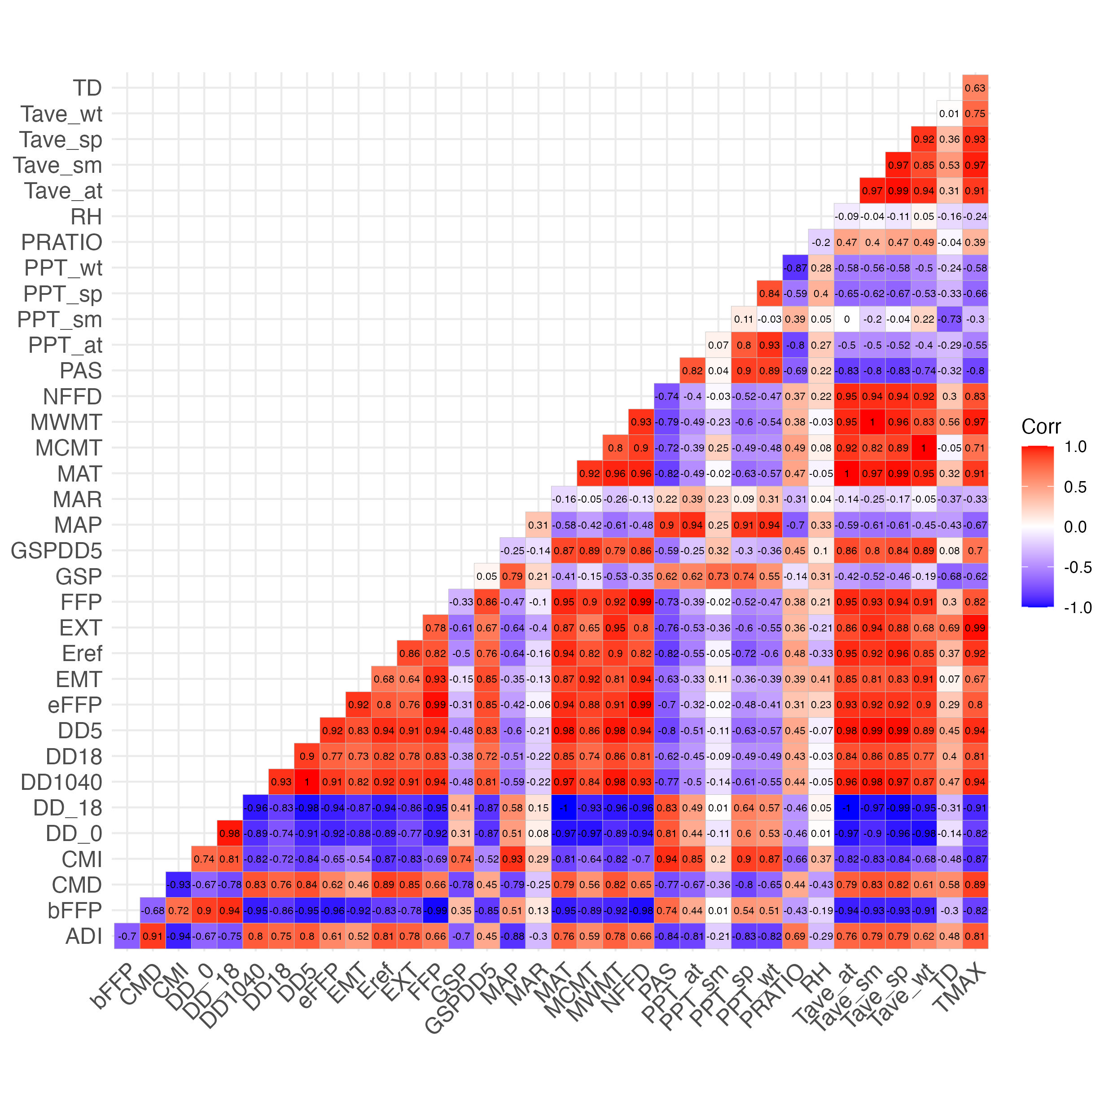

Figure 7: Correlation coefficients between pairs of climate predictor variables examined for inclusion in SDM

# Appendix C: Supplemental figures

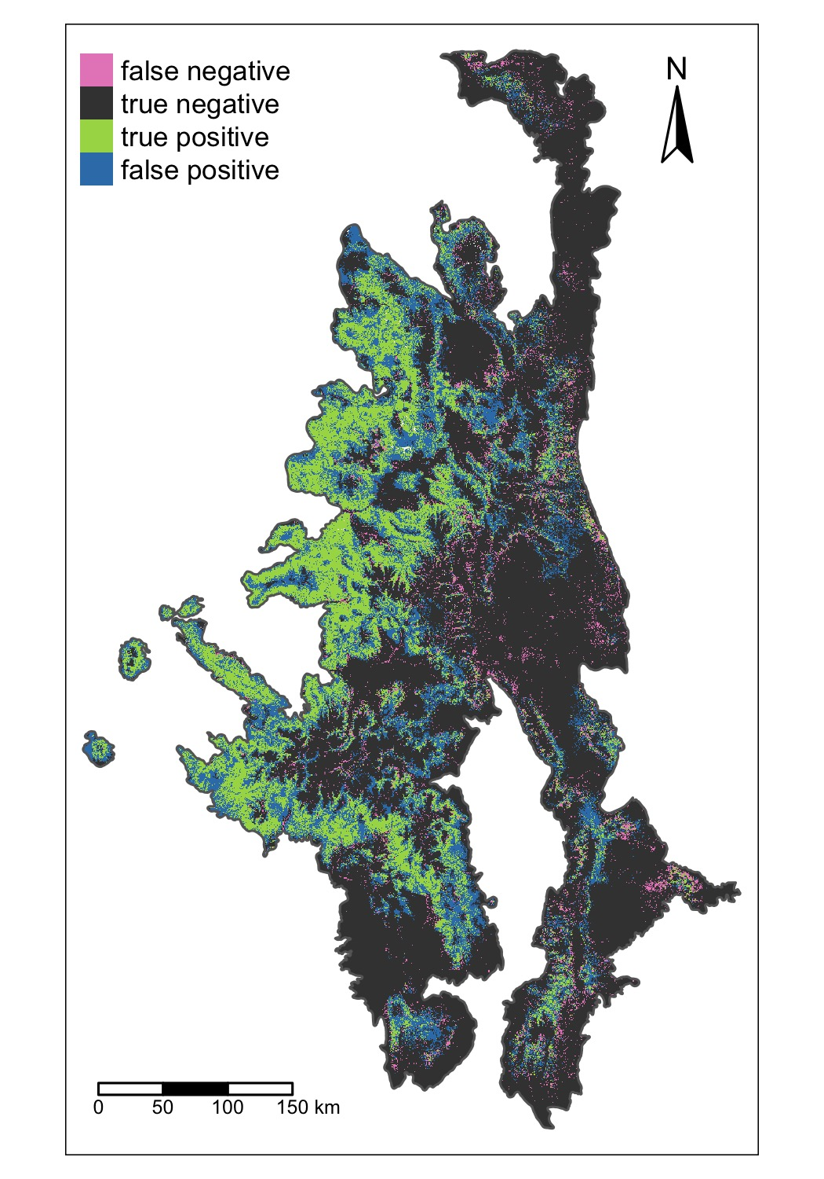

Figure 8: Spatial patterns of missclassification for the ensemble model.

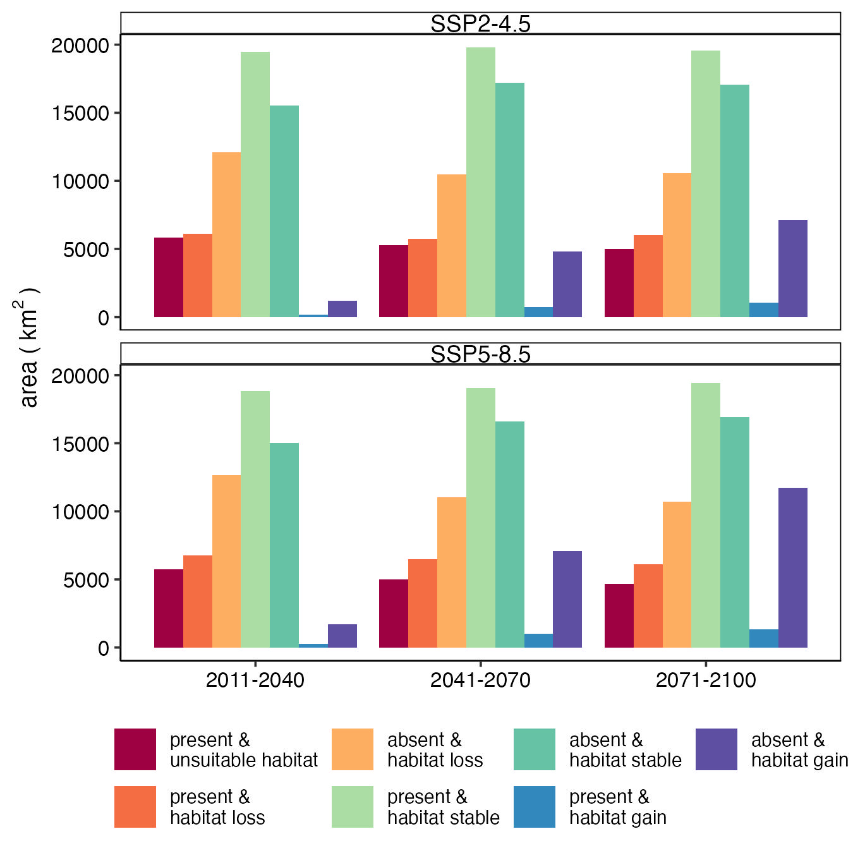

Figure 9: Barplots illustrating the temporal patterns in the areas were aspen my lost, gained, or remain stable based on the current distribution of aspen and the ensemeble SDM forecast of future aspen habitat suitability.

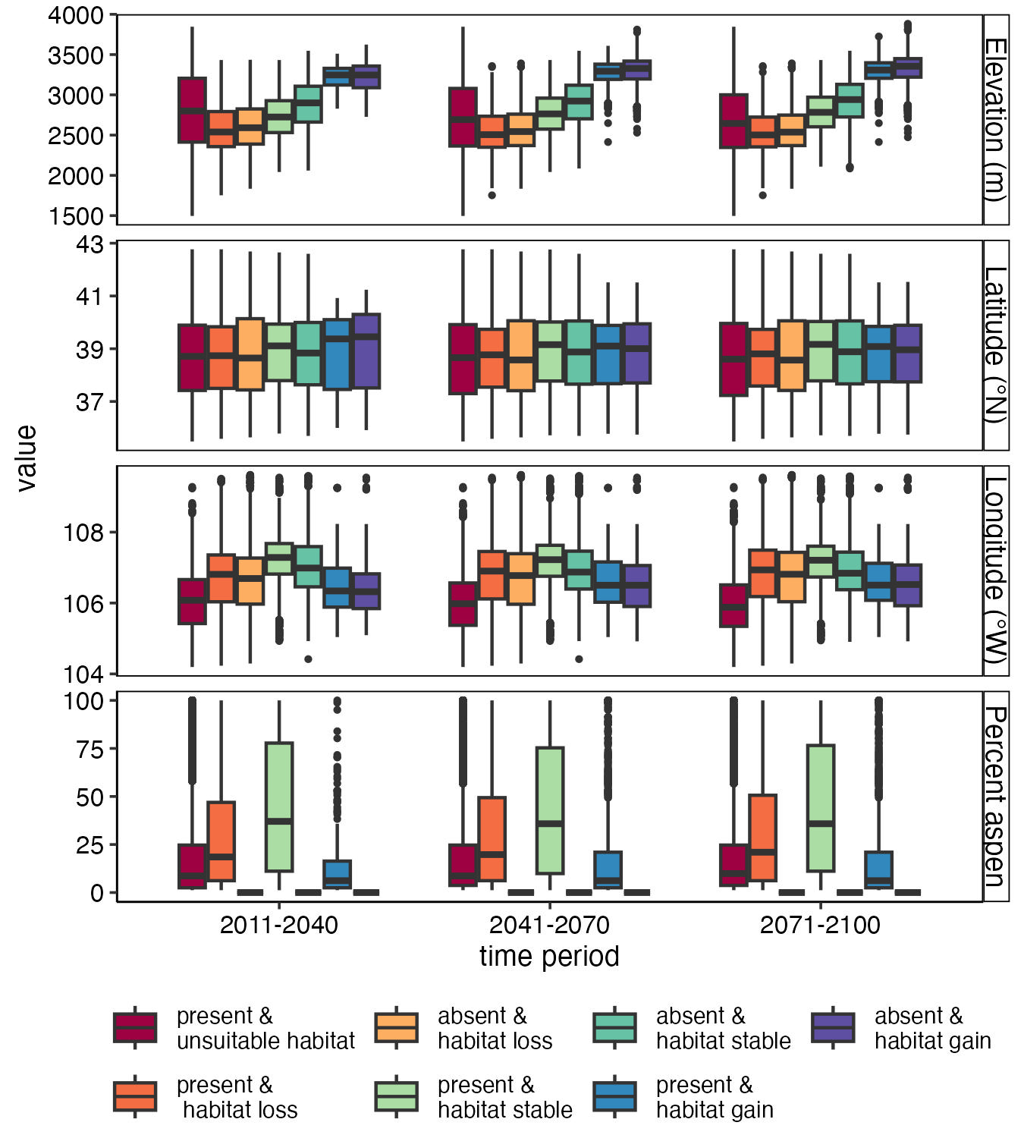

Figure 10: Boxplots illustrating spatial patterns in the areas were aspen my lost, gained, or remain stable based on the current distribution of aspen the ensemeble SDM forecast of future aspen habitat suitability under the SSP2-45 scenario.

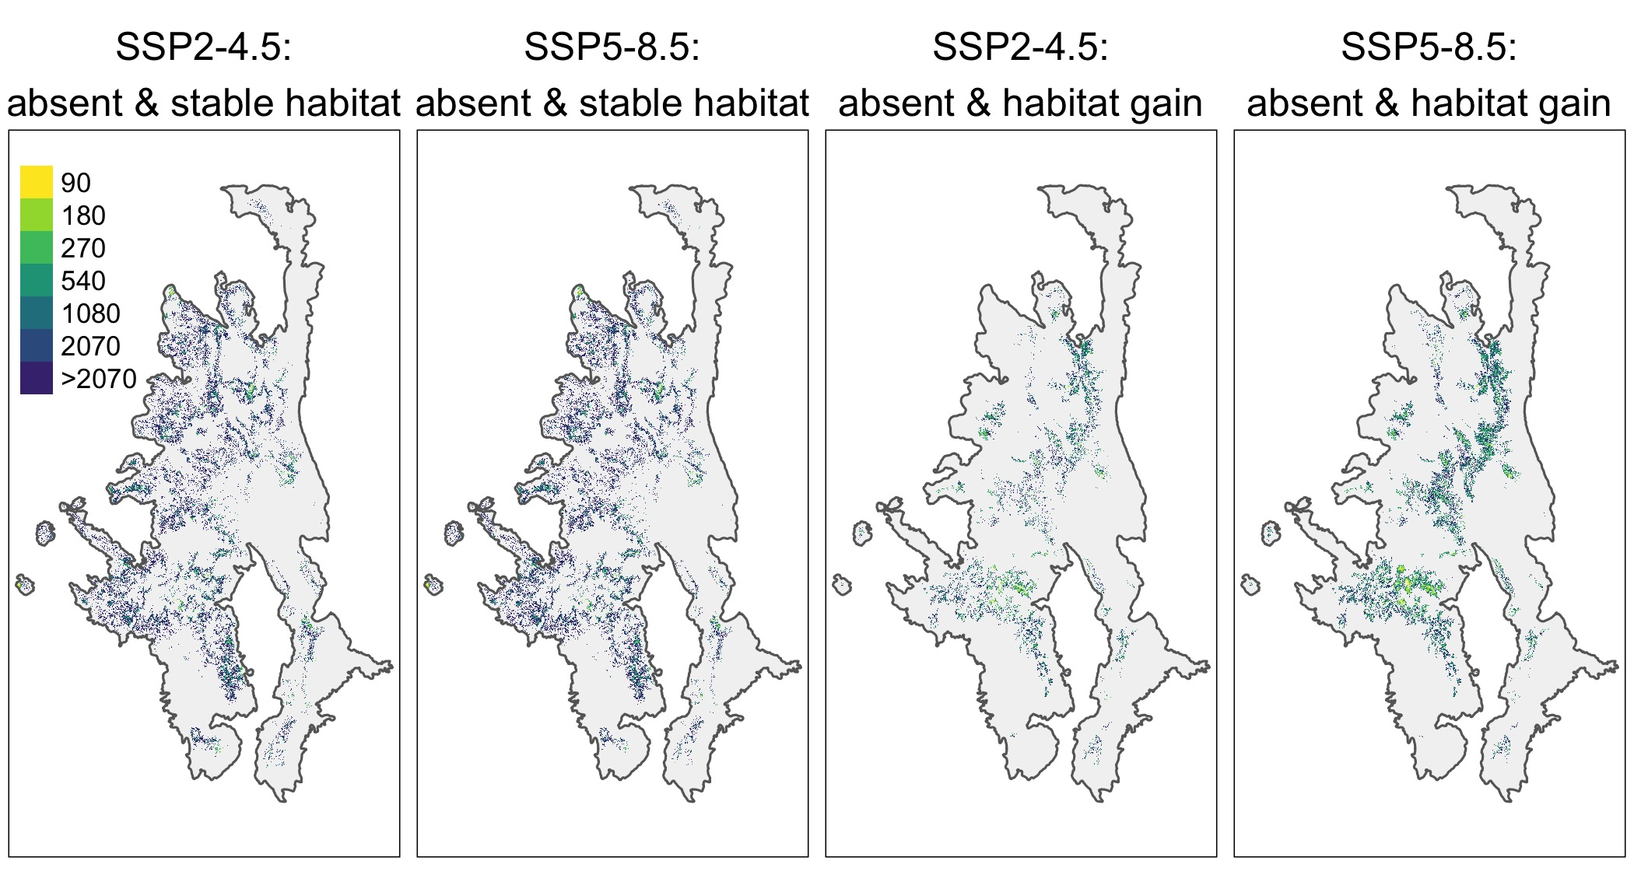

Figure 11: Distance to the nearest existing aspen patch for pixels were future climate may promote aspen expansion by 2100 under the SSP2-4.5 scenario.